OPERATOR MANUAL


REV | DATE | DISCRIPTION |  |  |  | DRAWN | CHECKED |  | APPPROVED
Amazon Logistics |  |  |  | Conveyor Logistics
 |  |  |  | 
PROJECT NO
CVL-2314
LOCATION  Brisbane – QLD |  |  | CONVEYOR SYSTEM
DOCUMENT No. Page REV.  V2 |  |  | PAGES |  |  |  |  | REV.  2/07/2024

THIS PAGE IS INTENTIONALLY LEFT BLANK

Summary

1. Summary 3
2. Figure Table. 5
3. Introduction 7
4. Brief system description 8
5. General distribution of the system. 9
6. General composition of the rollers with control card. 12
7. Cards and devices involved the system lanes. 13
7.1. Conveyor B (Lane 1) Devices. 15
7.2. Finger 3 (Lane 1) Devices. 19
7.3. Conveyor A (Lane 2) Devices. 22
7.4. Finger 1 (Lane 2) Devices. 25
7.5. Conveyor C (Lane 3) Devices. 28
7.6. Finger 2 (Lane 3) Devices. 30
7.7. Induct table 1 (Lane 4) Devices. 33
7.8. Takeaway conveyor 1 (Lane 5) Devices. 35
7.9. Induct table 2 (Lane 6) Devices. 37
7.10. Induct table 3 (Lane 7) Devices. 39
7.11. Induct table 4 (Lane 8) Devices. 41
7.12. Takeaway conveyor 2 (Lane 9) Devices. 43
7.13. Induct table 5 (Lane 10) Devices. 45
7.14. Induct table 6 (Lane 11) Devices. 47
7.15. Takeaway conveyor 3 (Lane 12) Devices. 49
7.16. Induct table 7 (Lane 13) Devices. 51
7.17. Transfer Rollers (Section 14) Devices. 53
8. Control system. 54
8.1. Pushbuttons, Selectors and indicators. 54
8.1.1. Control from main control panel. 55
8.1.2. Push buttons, selector, and indicator for Fingers. 60
8.1.3. Push buttons and selector for Induct tables. 64
8.1.4. Push buttons and selector for Induct tables. 65
8.1.5. Push buttons for Takeaway conveyor. 66
8.1.6. General Emergency stop and lanyards. 67
8.2. HMI navigation. 69
8.3. HMI Main Screen. 71
8.4. HMI Overview Screen. 74
8.5. HMI Lanes Screen. 80
8.5.1. Motors animations. 88
8.5.2. Sensor animations, HMI overview screen. 90
8.5.3. HMI Motors Popup Screen. 91
8.5.4. HMI Sensors Popup Screen. 95
8.6. HMI Maintenance Screen. 98
8.7. HMI Settings Screen. 101
8.8. HMI Alarm Screen. 105
9. References. 107
10. Glossary 109

Figure Table.

Figure 1. Top view, conveyor system 9
Figure 2. General composition of the Rollers. 12
Figure 3. General composition of the rollers master-slave control cards. 13
Figure 4. General composition of the rollers Master-slave control cards including Interroll card. 14
Figure 5. General composition of the Conveyor B (Lane 1). 15
Figure 6. HMI Sensors Conveyor B (Lane 1). 18
Figure 7. General composition of the Finger 3 (Lane 1). 19
Figure 8. HMI Sensors Finger 3 DIST-01-13 (Lane 1). 20
Figure 9. HMI Sensors Finger 3 DIST-01-16 (Lane 1). 21
Figure 10. General composition of the Conveyor A (Lane 2). 22
Figure 11. HMI Sensors Conveyor A (Lane 2). 24
Figure 12. General composition of the Finger 3 (Lane 1). 25
Figure 13. HMI Sensors Finger 1 DIST-02-09 (Lane 2). 26
Figure 14. HMI Sensors Finger 1 DIST-02-12 (Lane 2). 27
Figure 15. General composition of the Conveyor C (Lane 3). 28
Figure 16. HMI Sensors Conveyor C (Lane 3). 29
Figure 17. General composition of the Finger 3 (Lane 1). 30
Figure 18. HMI Sensors Finger 2 DIST-03-03 (Lane 3). 31
Figure 19. HMI Sensors Finger 2 DIST-03-06 (Lane 3). 32
Figure 20. HMI Sensors Induct table 2 DIST-06-01 (Lane 6). 38
Figure 21. Direction of Transfer rollers when Conveyor B is enabled/disabled 53
Figure 22. Main control panel MCC. 55
Figure 23. Main control panel MCC. 56
Figure 24. Main Panel Light Tower. 58
Figure 25. Local control Fingers. 60
Figure 26. Local control slowdown push button Fingers. 61
Figure 27. Local indicator Fingers. 62
Figure 28. Local Jam reset control and indicator Fingers. 63
Figure 29. Local control slowdown push button and white indicator Conveyor B. 64
Figure 30. Local control Induct Tables. 65
Figure 31. Local control Takeaway conveyor. 66
Figure 32. Top view, conveyor system1. 67
Figure 33. HMI navigation. 69
Figure 34. HMI navigation. 70
Figure 35. HMI Main Screen. 71
Figure 36. HMI Overview Screen. 74
Figure 37. HMI pop-up window Lane general status. 74
Figure 38. Lane control mode indicator. 75
Figure 39. Lane status indicator. 76
Figure 40. Lane status indicator. 77
Figure 41. Lane Rollers Status Indicator. 77
Figure 42. Lane Speed indicator. 77
Figure 43. Slowdown Speed indicator. 78
Figure 44. Flow direction indicator. 78
Figure 45. Animation of the Zones. 79
Figure 46. Animation of the E-Stop. 79
Figure 47. HMI Lanes Screen. 80
Figure 48. HMI Zone general status. 82
Figure 49. Zone control mode indicator. 83
Figure 50. Zone status indicator. 84
Figure 51. Zone status indicator. 85
Figure 52. Zone Rollers Status Indicator. 86
Figure 53.Zone Speed indicator. 86
Figure 54. Zone Slowdown Speed indicator. 86
Figure 55. Zone Flow direction indicator. 86
Figure 56. Status of the devices in the zone 87
Figure 57. Status of the devices in the zone 87
Figure 58. Motor animations. 88
Figure 59. Motor animations. 89
Figure 60. Sensor animations. 90
Figure 61. HMI motor Popup Screen. 91
Figure 62. Popup Screen, motors animations status 93
Figure 63. Popup Screen, motors animations status 94
Figure 64. HMI sensor Popup Screen. 95
Figure 65. Popup Screen, sensor animations status 97
Figure 66. HMI Maintenance. 98
Figure 67. HMI Maintenance. 99
Figure 68. HMI Maintenance Control Card devices. 99
Figure 69. HMI Settings Screen. 101
Figure 70. Stop Runtime popup screen. 102
Figure 71. Login popup screen. 102
Figure 72. OS Comfort panel. 103
Figure 73. security screen and user management. Comfort panel. 103
Figure 74. User management. Comfort panel. 103
Figure 75. HMI Alarm Screen. 105

Introduction

This document refers to any information that is displayed on the plant HMIs delivered by Pac Technologies in accordance with the information of the equipment supplied and in accordance with the specifications provided by the customer and all those involved in the development of the system.

Brief system description

The conveyor classification system is composed of a series of equipment and subsystems that together have the purpose of automatically transporting and monitoring products. The line is a powered conveyor which is controlled by the conveyor systems PLC. The conveying system is designed for the transportation of containers from 1 of 7 induct tables, to 1 of 3 destination fingers. The sortation process is done manually, with the MHE system providing only the transportation method. Fingers and induct tables can be enabled and disabled to suit operator availability. The MHE can be run in automatic and manual modes, which are described further in this document.

General distribution of the system.
The system is composed of multiple electrical and mechanical equipment. The following figures show diagrams with a top view of the general layout of the lanes conveyor system.
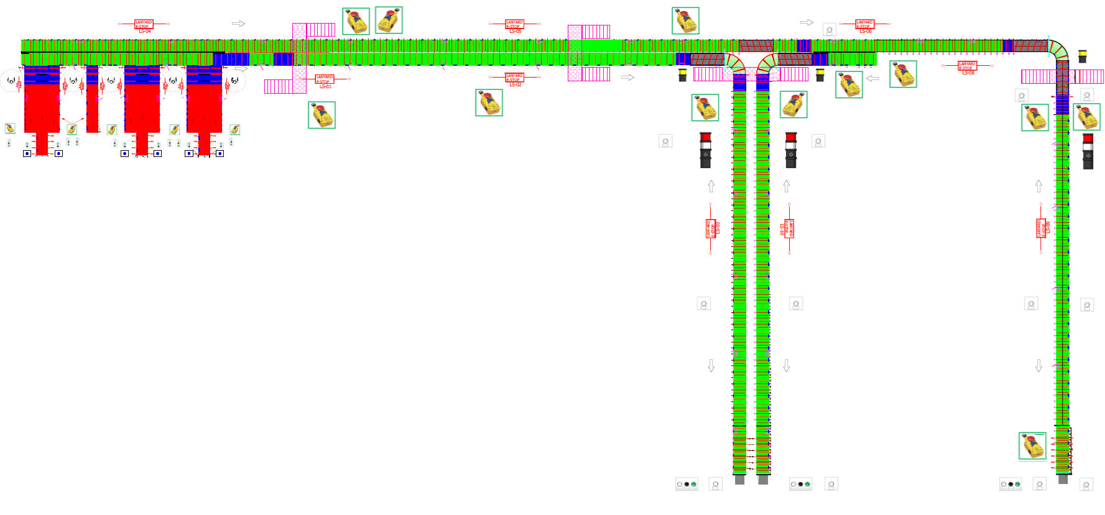
16
15
14
13
12
11
10
9
8
7
3
6
5
4
2
1
Figure 1. Top view, conveyor system

The System is composed for:
- Conveyor A (Lane2). Conveyor A is a transverse conveyor consisting of several MDR's and slave rollers. This conveyor acts as a single conveyor and behaves the same way a BUR conveyor would. The purpose of Conveyor A is to transport containers from the induct tables to Finger 1.

- Conveyor B (Lane 1). Conveyor B is a transverse conveyor consisting of several MDR’s and slave rollers. This conveyor acts as a single conveyor and behaves the same way a BUR conveyor would. The purpose of Conveyor B is to transport containers from the induct tables to Fingers 2 and 3.

- Conveyor C (Lane 3). Conveyor C is a transverse conveyor consisting of several MDR's and slave rollers. This conveyor acts as a single conveyor and behaves the same way a BUR conveyor would. The purpose of Conveyor C is to transport containers from the Conveyor B to Fingers 3.

- Finger 1 (Lane 2). Finger 1 is a sortation finger of the MHE. It consists of several MDR’s and slave rollers. This conveyor acts as a single conveyor and behaves the same way a BUR conveyor would, except for when the finger has filled up. Finger 1 has the ability to convert to a ZPA style conveyor, and also can run in reverse from the local control. The purpose of Finger 1 is to transport containers to operators for put away of containers.

- Finger 2 (Lane 3). Finger 2 is a sortation finger of the MHE. It consists of several MDR’s and slave rollers. This conveyor acts as a single conveyor and behaves the same way a BUR conveyor would, except for when the finger has filled up. Finger 2 has the ability to convert to a ZPA style conveyor, and also can run in reverse. The purpose of Finger 2 is to transport containers to operators for put away of containers.

- Finger 3 (Lane 1). Finger 3 is a sortation finger of the MHE. It consists of several MDR’s and slave rollers. This conveyor acts as a single conveyor and behaves the same way a BUR conveyor would, except for when the finger has filled up. Finger 3 has the ability to convert to a ZPA style conveyor, and also can run in reverse. The purpose of Finger 3 is to transport containers to operators for put away of containers.

- Induct table 1 (Lane 4). The purpose of Induction Table 1 is to introduce containers into the transportation system that travels in the direction of Conveyors A/B.

- Takeaway conveyor 1 (Lane 5). Induct tables and takeaway conveyor consists of a series of 3 conveyors. The 2 outside travelling in the direction of the Conveyors A/B, and the middle takeaway conveyor travelling in the opposite direction. The purpose of induction tables is to introduce containers into the conveying system while providing a method for removing unsuitable containers.

- Induct table 2 (Lane 6). The purpose of Induction Table 2 is to introduce containers into the transportation system that travels in the direction of Conveyors A/B.

- Induct table 3 (Lane 7). Induct table 3 consists of a single conveyor travelling in the direction of Conveyors A/B. Induct Table 2 has no takeaway conveyor. The purpose of Induct Table 2 is to induct containers into the conveying system.

- Induct table 4 (Lane 8). The purpose of Induction Table 4 is to introduce containers into the transportation system that travels in the direction of Conveyors A/B.

- Takeaway conveyor 2 (Lane 9). Induct tables and takeaway conveyor consists of a series of 3 conveyors. The 2 outside travelling in the direction of the Conveyors A/B, and the middle takeaway conveyor travelling in the opposite direction. The purpose of induction tables is to introduce containers into the conveying system while providing a method for removing unsuitable containers.

- Induct table 5 (Lane 10). The purpose of Induction Table 5 is to introduce containers into the transportation system that travels in the direction of Conveyors A/B.

- Induct table 6 (Lane 11). The purpose of Induction Table 6 is to introduce containers into the transportation system that travels in the direction of Conveyors A/B.

- Takeaway conveyor 3 (Lane 12). Induct tables and takeaway conveyor consists of a series of 3 conveyors. The 2 outside travelling in the direction of the Conveyors A/B, and the middle takeaway conveyor travelling in the opposite direction. The purpose of induction tables is to introduce containers into the conveying system while providing a method for removing unsuitable containers.

- Induct table 7 (Lane 13). The purpose of Induction Table 7 is to introduce containers into the transportation system that travels in the direction of Conveyors A/B.

General composition of the rollers with control card.

The following figure shows the general composition of the Rollers.

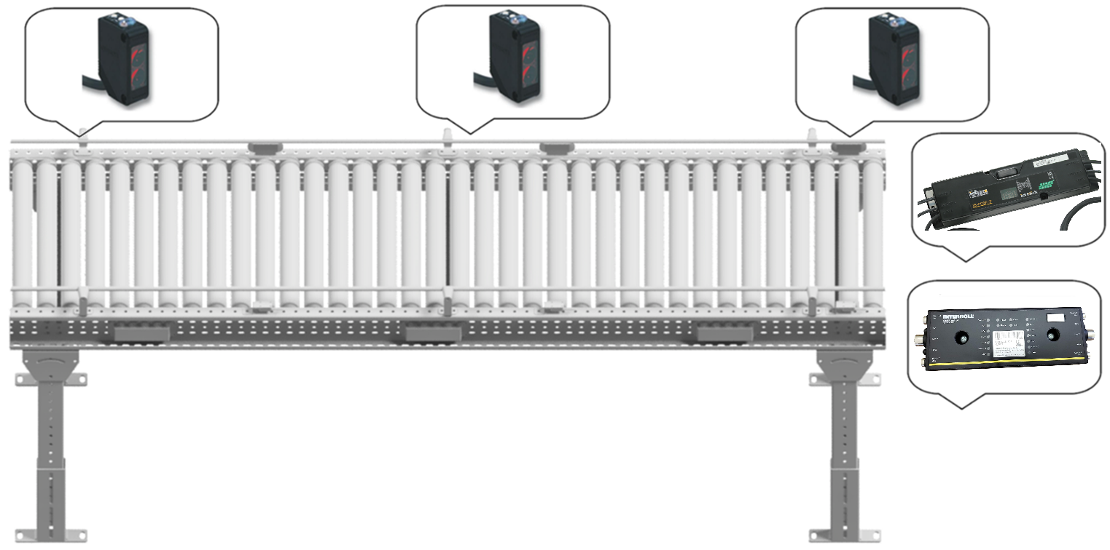
3
2
1
Figure 2. General composition of the Rollers.

The conveyor roller subsystem is composed of:
- Rollers: The rollers that have 24V motors and are controlled by the control cards with the main logic inside this card.

- Control cards. The control cards have the behaviour logic of the rollers, these cards communicate with each other to evaluate when they transport and when they stop, these cards are the ones that communicate with the PLC to determine when product is being entered in these lanes and when they must be stopped.

- Photo Electric Sensor. This sensor has the function of locating the product and the PLC can evaluate and determine if it can receive or send product to the other areas.

During operation ensure that the system is safe to operate. IT IS POSSIBLE TO DAMAGE THE EQUIPMENT AND INJURY PERSONNEL IN MANUAL OR AUTOMATIC MODE.
ONLY QUALIFIED PERSONNEL SHOULD OPERATE THIS MODE.
PAC TECHNOLOGIES REJECTS ANY REPONSIBILITY OF DAMAGE MADE TO EQUIPMENT AND PERSONNEL.

Cards and devices involved the system lanes.
Each section of the transportation system comprises various pieces of equipment, each with its own specific purpose and operation. Since the power source for the roller motors can support up to 16 motors, distribution panels were installed throughout the system to supply power. A separate power source is used for control and operation. For communication with the system's central controller, the PLC, a control card was configured as the master to manage seven slave cards. The following image shows the general layout of the master card and its slaves.

11
11
1
3
9
10
4
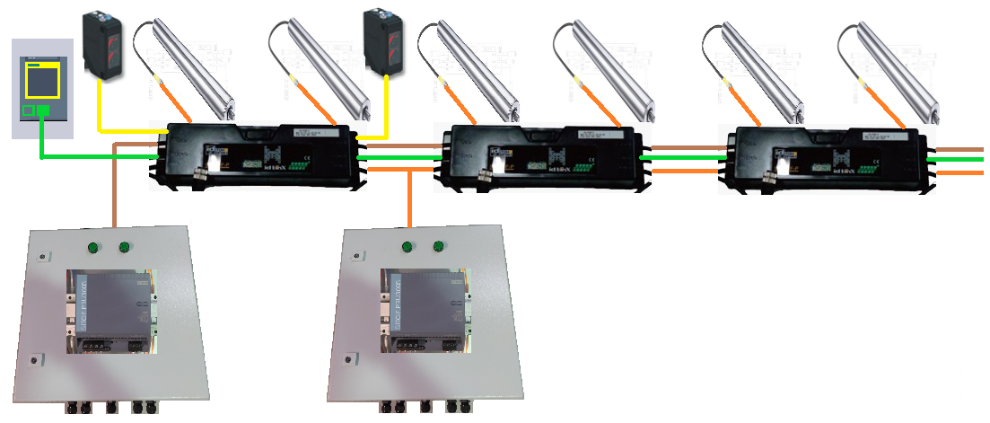
2
12
8
7
6
5
Figure 3. General composition of the rollers master-slave control cards.
The rollers master-slave control cards composed of:
- PLC: a programmable logic controller is an industrial computer control system that continuously monitors the state of input devices and makes decisions based upon a custom program to control the state of output devices.

- Profibus communication cable. PROFIBUS allows communication between devices of different manufacturers without any special interface adjustment. PROFIBUS can be used for both high-speed time critical applications and complex communication tasks.

- Master control card. The master control card is the primary card among the eight cards. Its function is to communicate with the PLC and its seven slave cards, exchanging information to start, stop, and monitor the motors and control cards based on the PLC's logic.

- Slaves control cards. Slave control cards communicate with the master card to start, stop, and monitor the motors and control cards according to the PLC logic.

- Control Power Supply for Control Cards. This power source provides 24V DC to the control cards, ensuring they continuously report their status to the PLC. Currently, only two distribution panels perform this function.

- Control Power Cable. The AS-i cable is capable of powering the control cards.

- Power Source for Roller Motors: This power source supplies the motors with the appropriate voltage and current to ensure proper operation.

- Motors Power Cable. The AS-i cable is capable of powering the motors of the control cards.

- Rollers A: The rollers that have 24Vdc motors and are controlled by the control cards and the PLC.

- Rollers B: The rollers that have 24Vdc motors and are controlled by the control cards and the PLC.

- Sensors A and B. The cards have the capacity to receive the signal from two sensors where these are programmed in PLC and can be used in the logic for the correct functioning of the system.

- Slaves control cards 3 to 7.

- Curve Interroll Card. For the curves where specific motors are managed, it was necessary to implement Interroll control cards. These cards can manage three rollers each and, due to their electronics, communicate directly with the PLC. The Profibus communication cable is daisy-chained with the master card, as shown in the figure.

- Rollers A, B and C: The rollers that have 24Vdc motors and are controlled by the control cards Interroll and the PLC.

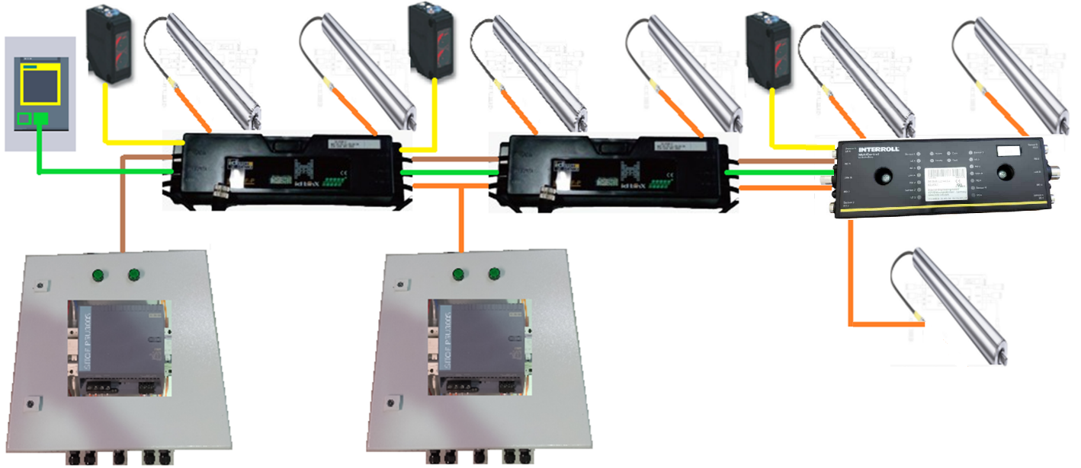
14
13
Figure 4. General composition of the rollers Master-slave control cards including Interroll card.

Conveyor B (Lane 1) Devices.

Conveyor B is the longest lane, featuring the highest number of distribution boards and control cards. It includes distribution boards DIST-01-01 through DIST-01-12, as illustrated in the following figure. The control power on the cards in this section was implemented from the RIO 1 distribution board.

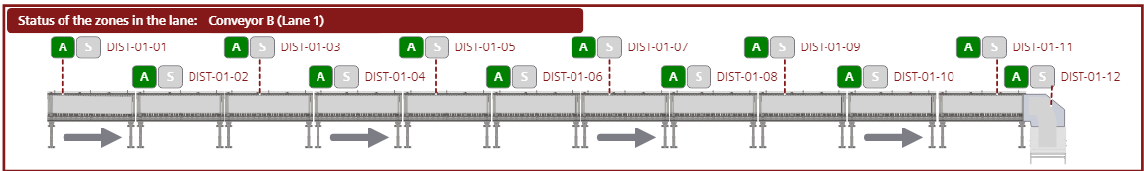
Figure 5. General composition of the Conveyor B (Lane 1).
The following Table shows the distribution boards, cards and motors activated for the operation of this lane.

DB ID | Card ID | Roller ID's
DIST-01-01 | DIST-01-01.CAR.1 | DIST-01-01.CAR.1.ROL.A
 |  | DIST-01-01.CAR.1.ROL.B
 | DIST-01-01.CAR.2 | DIST-01-01.CAR.2.ROL.A
 |  | DIST-01-01.CAR.2.ROL.B
 | DIST-01-01.CAR.3 | DIST-01-01.CAR.3.ROL.A
 |  | DIST-01-01.CAR.3.ROL.B
 | DIST-01-01.CAR.4 | DIST-01-01.CAR.4.ROL.A
 |  | DIST-01-01.CAR.4.ROL.B
 | DIST-01-01.CAR.5 | DIST-01-01.CAR.5.ROL.A
 |  | DIST-01-01.CAR.5.ROL.B
 | DIST-01-01.CAR.6 | DIST-01-01.CAR.6.ROL.A
 |  | DIST-01-01.CAR.6.ROL.B
 | DIST-01-01.CAR.7 | DIST-01-01.CAR.7.ROL.A
 |  | DIST-01-01.CAR.7.ROL.B
DIST-01-02 | DIST-01-02.CAR.1 | DIST-01-02.CAR.1.ROL.A
 |  | DIST-01-02.CAR.1.ROL.B
 | DIST-01-02.CAR.2 | DIST-01-02.CAR.2.ROL.A
 |  | DIST-01-02.CAR.2.ROL.B
 | DIST-01-02.CAR.3 | DIST-01-02.CAR.3.ROL.A
 |  | DIST-01-02.CAR.3.ROL.B
 | DIST-01-02.CAR.4 | DIST-01-02.CAR.4.ROL.A
 |  | DIST-01-02.CAR.4.ROL.B
 | DIST-01-02.CAR.5 | DIST-01-02.CAR.5.ROL.A
 |  | DIST-01-02.CAR.5.ROL.B
 | DIST-01-02.CAR.6 | DIST-01-02.CAR.6.ROL.A
 |  | DIST-01-02.CAR.6.ROL.B

DB ID | Card ID | Roller ID's
DIST-01-02 | DIST-01-02.CAR.7 | DIST-01-02.CAR.7.ROL.A
 |  | DIST-01-02.CAR.7.ROL.B
 | DIST-01-02.CAR.8 | DIST-01-02.CAR.8.ROL.A
 |  | DIST-01-02.CAR.8.ROL.B
DIST-01-03 | DIST-01-03.CAR.1 | DIST-01-03.CAR.1.ROL.A
 |  | DIST-01-03.CAR.1.ROL.B
 | DIST-01-03.CAR.2 | DIST-01-03.CAR.2.ROL.A
 |  | DIST-01-03.CAR.2.ROL.B
 | DIST-01-03.CAR.3 | DIST-01-03.CAR.3.ROL.A
 |  | DIST-01-03.CAR.3.ROL.B
 | DIST-01-03.CAR.4 | DIST-01-03.CAR.4.ROL.A
 |  | DIST-01-03.CAR.4.ROL.B
 | DIST-01-03.CAR.5 | DIST-01-03.CAR.5.ROL.A
 |  | DIST-01-03.CAR.5.ROL.B
 | DIST-01-03.CAR.6 | DIST-01-03.CAR.6.ROL.A
 |  | DIST-01-03.CAR.6.ROL.B
 | DIST-01-03.CAR.7 | DIST-01-03.CAR.7.ROL.A
 |  | DIST-01-03.CAR.7.ROL.B
 | DIST-01-03.CAR.8 | DIST-01-03.CAR.8.ROL.A
 |  | DIST-01-03.CAR.8.ROL.B
DIST-01-04 | DIST-01-04.CAR.1 | DIST-01-04.CAR.1.ROL.A
 |  | DIST-01-04.CAR.1.ROL.B
 | DIST-01-04.CAR.2 | DIST-01-04.CAR.2.ROL.A
 |  | DIST-01-04.CAR.2.ROL.B
 | DIST-01-04.CAR.3 | DIST-01-04.CAR.3.ROL.A
 |  | DIST-01-04.CAR.3.ROL.B

DB ID | Card ID | Roller ID's
DIST-01-04 | DIST-01-04.CAR.4 | DIST-01-04.CAR.4.ROL.A
 |  | DIST-01-04.CAR.4.ROL.B
 | DIST-01-04.CAR.5 | DIST-01-04.CAR.5.ROL.A
 |  | DIST-01-04.CAR.5.ROL.B
 | DIST-01-04.CAR.6 | DIST-01-04.CAR.6.ROL.A
 |  | DIST-01-04.CAR.6.ROL.B
 | DIST-01-04.CAR.7 | DIST-01-04.CAR.7.ROL.A
 |  | DIST-01-04.CAR.7.ROL.B
 | DIST-01-04.CAR.8 | DIST-01-04.CAR.8.ROL.A
 |  | DIST-01-04.CAR.8.ROL.B
DIST-01-05 | DIST-01-05.CAR.1 | DIST-01-05.CAR.1.ROL.A
 |  | DIST-01-05.CAR.1.ROL.B
 | DIST-01-05.CAR.2 | DIST-01-05.CAR.2.ROL.A
 |  | DIST-01-05.CAR.2.ROL.B
 | DIST-01-05.CAR.3 | DIST-01-05.CAR.3.ROL.A
 |  | DIST-01-05.CAR.3.ROL.B
 | DIST-01-05.CAR.4 | DIST-01-05.CAR.4.ROL.A
 |  | DIST-01-05.CAR.4.ROL.B
 | DIST-01-05.CAR.5 | DIST-01-05.CAR.5.ROL.A
 |  | DIST-01-05.CAR.5.ROL.B
 | DIST-01-05.CAR.6 | DIST-01-05.CAR.6.ROL.A
 |  | DIST-01-05.CAR.6.ROL.B
 | DIST-01-05.CAR.7 | DIST-01-05.CAR.7.ROL.A
 |  | DIST-01-05.CAR.7.ROL.B
 | DIST-01-05.CAR.8 | DIST-01-05.CAR.8.ROL.A
 |  | DIST-01-05.CAR.8.ROL.B
DIST-01-06 | DIST-01-06.CAR.1 | DIST-01-06.CAR.1.ROL.A
 |  | DIST-01-06.CAR.1.ROL.B
 | DIST-01-06.CAR.2 | DIST-01-06.CAR.2.ROL.A
 |  | DIST-01-06.CAR.2.ROL.B
 | DIST-01-06.CAR.3 | DIST-01-06.CAR.3.ROL.A
 |  | DIST-01-06.CAR.3.ROL.B
 | DIST-01-06.CAR.4 | DIST-01-06.CAR.4.ROL.A
 |  | DIST-01-06.CAR.4.ROL.B
 | DIST-01-06.CAR.5 | DIST-01-06.CAR.5.ROL.A
 |  | DIST-01-06.CAR.5.ROL.B
 | DIST-01-06.CAR.6 | DIST-01-06.CAR.6.ROL.A
 |  | DIST-01-06.CAR.6.ROL.B

DB ID | Card ID | Roller ID's
DIST-01-06 | DIST-01-06.CAR.7 | DIST-01-06.CAR.7.ROL.A
 |  | DIST-01-06.CAR.7.ROL.B
 | DIST-01-06.CAR.8 | DIST-01-06.CAR.8.ROL.A
 |  | DIST-01-06.CAR.8.ROL.B
DIST-01-07 | DIST-01-07.CAR.1 | DIST-01-07.CAR.1.ROL.A
 |  | DIST-01-07.CAR.1.ROL.B
 | DIST-01-07.CAR.2 | DIST-01-07.CAR.2.ROL.A
 |  | DIST-01-07.CAR.2.ROL.B
 | DIST-01-07.CAR.3 | DIST-01-07.CAR.3.ROL.A
 |  | DIST-01-07.CAR.3.ROL.B
 | DIST-01-07.CAR.4 | DIST-01-07.CAR.4.ROL.A
 |  | DIST-01-07.CAR.4.ROL.B
 | DIST-01-07.CAR.5 | DIST-01-07.CAR.5.ROL.A
 |  | DIST-01-07.CAR.5.ROL.B
 | DIST-01-07.CAR.6 | DIST-01-07.CAR.6.ROL.A
 |  | DIST-01-07.CAR.6.ROL.B
 | DIST-01-07.CAR.7 | DIST-01-07.CAR.7.ROL.A
 |  | DIST-01-07.CAR.7.ROL.B
 | DIST-01-07.CAR.8 | DIST-01-07.CAR.8.ROL.A
 |  | DIST-01-07.CAR.8.ROL.B
DIST-01-08 | DIST-01-08.CAR.1 | DIST-01-08.CAR.1.ROL.A
 |  | DIST-01-08.CAR.1.ROL.B
 | DIST-01-08.CAR.2 | DIST-01-08.CAR.2.ROL.A
 |  | DIST-01-08.CAR.2.ROL.B
 | DIST-01-08.CAR.3 | DIST-01-08.CAR.3.ROL.A
 |  | DIST-01-08.CAR.3.ROL.B
 | DIST-01-08.CAR.4 | DIST-01-08.CAR.4.ROL.A
 |  | DIST-01-08.CAR.4.ROL.B
 | DIST-01-08.CAR.5 | DIST-01-08.CAR.5.ROL.A
 |  | DIST-01-08.CAR.5.ROL.B
 | DIST-01-08.CAR.6 | DIST-01-08.CAR.6.ROL.A
 |  | DIST-01-08.CAR.6.ROL.B
 | DIST-01-08.CAR.7 | DIST-01-08.CAR.7.ROL.A
 |  | DIST-01-08.CAR.7.ROL.B
 | DIST-01-08.CAR.8 | DIST-01-08.CAR.8.ROL.A
 |  | DIST-01-08.CAR.8.ROL.B
DIST-01-09 | DIST-01-09.CAR.1 | DIST-01-09.CAR.1.ROL.A
 |  | DIST-01-09.CAR.1.ROL.B

DB ID | Card ID | Roller ID's
DIST-01-09 | DIST-01-09.CAR.2 | DIST-01-09.CAR.2.ROL.A
 |  | DIST-01-09.CAR.2.ROL.B
 | DIST-01-09.CAR.3 | DIST-01-09.CAR.3.ROL.A
 |  | DIST-01-09.CAR.3.ROL.B
 | DIST-01-09.CAR.4 | DIST-01-09.CAR.4.ROL.A
 |  | DIST-01-09.CAR.4.ROL.B
 | DIST-01-09.CAR.5 | DIST-01-09.CAR.5.ROL.A
 |  | DIST-01-09.CAR.5.ROL.B
 | DIST-01-09.CAR.6 | DIST-01-09.CAR.6.ROL.A
 |  | DIST-01-09.CAR.6.ROL.B
 | DIST-01-09.CAR.7 | DIST-01-09.CAR.7.ROL.A
 |  | DIST-01-09.CAR.7.ROL.B
DIST-01-10 | DIST-01-10.CAR.1 | DIST-01-10.CAR.1.ROL.A
 |  | DIST-01-10.CAR.1.ROL.B
 | DIST-01-10.CAR.2 | DIST-01-10.CAR.2.ROL.A
 |  | DIST-01-10.CAR.2.ROL.B
 | DIST-01-10.CAR.3 | DIST-01-10.CAR.3.ROL.A
 |  | DIST-01-10.CAR.3.ROL.B
 | DIST-01-10.CAR.4 | DIST-01-10.CAR.4.ROL.A
 |  | DIST-01-10.CAR.4.ROL.B
 | DIST-01-10.CAR.5 | DIST-01-10.CAR.5.ROL.A
 |  | DIST-01-10.CAR.5.ROL.B
 | DIST-01-10.CAR.6 | DIST-01-10.CAR.6.ROL.A
 |  | DIST-01-10.CAR.6.ROL.B
 | DIST-01-10.CAR.7 | DIST-01-10.CAR.7.ROL.A
 |  | DIST-01-10.CAR.7.ROL.B
 | DIST-01-10.CAR.8 | DIST-01-10.CAR.8.ROL.A
 |  | DIST-01-10.CAR.8.ROL.B
DIST-01-11 | DIST-01-11.CAR.1 | DIST-01-11.CAR.1.ROL.A
 |  | DIST-01-11.CAR.1.ROL.B
DB ID | Card ID | Roller ID's
DIST-01-11 | DIST-01-11.CAR.2 | DIST-01-11.CAR.2.ROL.A
 |  | DIST-01-11.CAR.2.ROL.B
 | DIST-01-11.CAR.3 | DIST-01-11.CAR.3.ROL.A
 |  | DIST-01-11.CAR.3.ROL.B
 | DIST-01-11.CAR.4 | DIST-01-11.CAR.4.ROL.A
 |  | DIST-01-11.CAR.4.ROL.B
 | DIST-01-11.CAR.5 | DIST-01-11.CAR.5.ROL.A
 |  | DIST-01-11.CAR.5.ROL.B
 | DIST-01-11.CAR.6 | DIST-01-11.CAR.6.ROL.A
 |  | DIST-01-11.CAR.6.ROL.B
 | DIST-01-11.CAR.7 | DIST-01-11.CAR.7.ROL.A
 |  | DIST-01-11.CAR.7.ROL.B
 | DIST-01-11.CAR.8 | DIST-01-11.CAR.8.ROL.A
 |  | DIST-01-11.CAR.8.ROL.B
DIST-01-12 | DIST-01-12.CAR.1 | DIST-01-12.CAR.1.ROL.A
 |  | DIST-01-12.CAR.1.ROL.B
 | DIST-01-12.CAR.2 | DIST-01-12.CAR.2.ROL.A
 |  | DIST-01-12.CAR.2.ROL.B
 | DIST-01-12.CAR.3 | DIST-01-12.CAR.3.ROL.A
 |  | DIST-01-12.CAR.3.ROL.B
 | DIST-01-12.CAR.4 | DIST-01-12.CAR.4.ROL.A
 |  | DIST-01-12.CAR.4.ROL.B
 | DIST-01-12.CAR.5 | DIST-01-12.CAR.5.ROL.A
 |  | DIST-01-12.CAR.5.ROL.B
 | DIST-01-12.CAR.6 | DIST-01-12.CAR.6.ROL.A
 |  | DIST-01-12.CAR.6.ROL.B
 | DIST-01-12.CAR.7 | DIST-01-12.CAR.7.ROL.A
 | Interroll card | DIST-01-12.CAR.7.ROL.B
 | Interroll card | DIST-01-12.CAR.7.ROL.C

In this section, only one sensor was implemented at the curve or departure of the lane. The system determines the downstream state, checking if the finger is stopped or if the product flow direction is opposite. When a box is detected by this sensor, the lane will stop to prevent collisions between the transported products. The following figure and table show the sensor described above.

DB ID | Card ID | Sensor ID's
DIST-01-12 | DIST-01-12.CAR.7 | DIST-01-12.CAR.7.SEN.A
 |  | Disabled

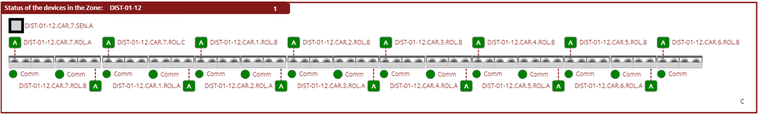
Figure 6. HMI Sensors Conveyor B (Lane 1).

Finger 3 (Lane 1) Devices.

Once the unit transported by Conveyor B leaves this lane, it enters Finger 3, where it is transported and received by the operator. This lane consists of distribution boards DIST-01-13 through DIST-01-16, as illustrated in the following figure. The control power on the cards in this section was implemented from the RIO 1 distribution board.

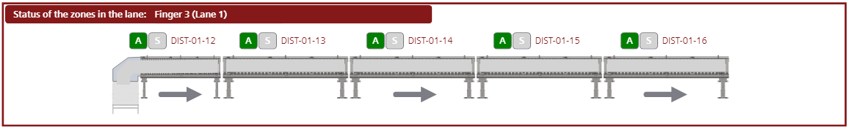
Figure 7. General composition of the Finger 3 (Lane 1).
The following Table shows the distribution boards, cards and motors activated for the operation of this lane.

DB ID | Card ID | Roller ID's
DIST-01-13 | DIST-01-13.CAR.1 | Disabled
 |  | DIST-01-13.CAR.1.ROL.B
 | DIST-01-13.CAR.2 | DIST-01-13.CAR.2.ROL.A
 |  | DIST-01-13.CAR.2.ROL.B
 | DIST-01-13.CAR.3 | DIST-01-13.CAR.3.ROL.A
 |  | DIST-01-13.CAR.3.ROL.B
 | DIST-01-13.CAR.4 | DIST-01-13.CAR.4.ROL.A
 |  | DIST-01-13.CAR.4.ROL.B
 | DIST-01-13.CAR.5 | DIST-01-13.CAR.5.ROL.A
 |  | DIST-01-13.CAR.5.ROL.B
 | DIST-01-13.CAR.6 | DIST-01-13.CAR.6.ROL.A
 |  | DIST-01-13.CAR.6.ROL.B
 | DIST-01-13.CAR.7 | DIST-01-13.CAR.7.ROL.A
 |  | DIST-01-13.CAR.7.ROL.B
 | DIST-01-13.CAR.8 | DIST-01-13.CAR.8.ROL.A
 |  | DIST-01-13.CAR.8.ROL.B
DIST-01-14 | DIST-01-14.CAR.1 | DIST-01-14.CAR.1.ROL.A
 |  | DIST-01-14.CAR.1.ROL.B
 | DIST-01-14.CAR.2 | DIST-01-14.CAR.2.ROL.A
 |  | DIST-01-14.CAR.2.ROL.B
 | DIST-01-14.CAR.3 | DIST-01-14.CAR.3.ROL.A
 |  | DIST-01-14.CAR.3.ROL.B
 | DIST-01-14.CAR.4 | DIST-01-14.CAR.4.ROL.A
 |  | DIST-01-14.CAR.4.ROL.B
 | DIST-01-14.CAR.5 | DIST-01-14.CAR.5.ROL.A

DB ID | Card ID | Roller ID's
DIST-01-14 | DIST-01-14.CAR.5 | DIST-01-14.CAR.5.ROL.B
 | DIST-01-14.CAR.6 | DIST-01-14.CAR.6.ROL.A
 |  | DIST-01-14.CAR.6.ROL.B
 | DIST-01-14.CAR.7 | DIST-01-14.CAR.7.ROL.A
 |  | DIST-01-14.CAR.7.ROL.B
 | DIST-01-14.CAR.8 | DIST-01-14.CAR.8.ROL.A
 |  | DIST-01-14.CAR.8.ROL.B
DIST-01-15 | DIST-01-15.CAR.1 | DIST-01-15.CAR.1.ROL.A
 |  | DIST-01-15.CAR.1.ROL.B
 | DIST-01-15.CAR.2 | DIST-01-15.CAR.2.ROL.A
 |  | DIST-01-15.CAR.2.ROL.B
 | DIST-01-15.CAR.3 | DIST-01-15.CAR.3.ROL.A
 |  | DIST-01-15.CAR.3.ROL.B
 | DIST-01-15.CAR.4 | DIST-01-15.CAR.4.ROL.A
 |  | DIST-01-15.CAR.4.ROL.B
 | DIST-01-15.CAR.5 | DIST-01-15.CAR.5.ROL.A
 |  | DIST-01-15.CAR.5.ROL.B
 | DIST-01-15.CAR.6 | DIST-01-15.CAR.6.ROL.A
 |  | DIST-01-15.CAR.6.ROL.B
 | DIST-01-15.CAR.7 | DIST-01-15.CAR.7.ROL.A
 |  | DIST-01-15.CAR.7.ROL.B
 | DIST-01-15.CAR.8 | DIST-01-15.CAR.8.ROL.A
 |  | DIST-01-15.CAR.8.ROL.B
DIST-01-16 | DIST-01-16.CAR.1 | DIST-01-16.CAR.1.ROL.A
 |  | DIST-01-16.CAR.1.ROL.B

DB ID | Card ID | Roller ID's
DIST-01-16 | DIST-01-16.CAR.2 | DIST-01-16.CAR.2.ROL.A
 |  | DIST-01-16.CAR.2.ROL.B
 | DIST-01-16.CAR.3 | DIST-01-16.CAR.3.ROL.A
 |  | DIST-01-16.CAR.3.ROL.B
 | DIST-01-16.CAR.4 | DIST-01-16.CAR.4.ROL.A
 |  | DIST-01-16.CAR.4.ROL.B
 | DIST-01-16.CAR.5 | DIST-01-16.CAR.5.ROL.A
 |  | DIST-01-16.CAR.5.ROL.B
 | DIST-01-16.CAR.6 | DIST-01-16.CAR.6.ROL.A
 |  | DIST-01-16.CAR.6.ROL.B
 | DIST-01-16.CAR.7 | DIST-01-16.CAR.7.ROL.A
 |  | DIST-01-16.CAR.7.ROL.B
 | DIST-01-16.CAR.8 | DIST-01-16.CAR.8.ROL.A
 |  | DIST-01-16.CAR.8.ROL.B

This conveyor acts as a single conveyor and behaves the same way a BUR conveyor would, except for when the finger has filled up. Finger 3 has the ability to convert to a ZPA style conveyor. The sensors involved in this section are shown in the following table and figure.

DB ID | Card ID | Sensor ID's
DIST-01-13 | DIST-01-13.CAR.1 | Disabled
 |  | DIST-01-13.CAR.1.SEN.B
DIST-01-16 | DIST-01-16.CAR.5 | Disabled
 |  | DIST-01-16.CAR.5.SEN.B
 | DIST-01-16.CAR.6 | DIST-01-16.CAR.6.SEN.A
 |  | DIST-01-16.CAR.6.SEN.B
 | DIST-01-16.CAR.7 | DIST-01-16.CAR.7.SEN.A
 |  | DIST-01-16.CAR.7.SEN.B
 | DIST-01-16.CAR.8 | DIST-01-16.CAR.8.SEN.A
 |  | Disabled

The next sensor shown in the figure behaves like ZPA but when the transport flow direction is changed this sensor stops the Finger to avoid collisions between boxes or units.
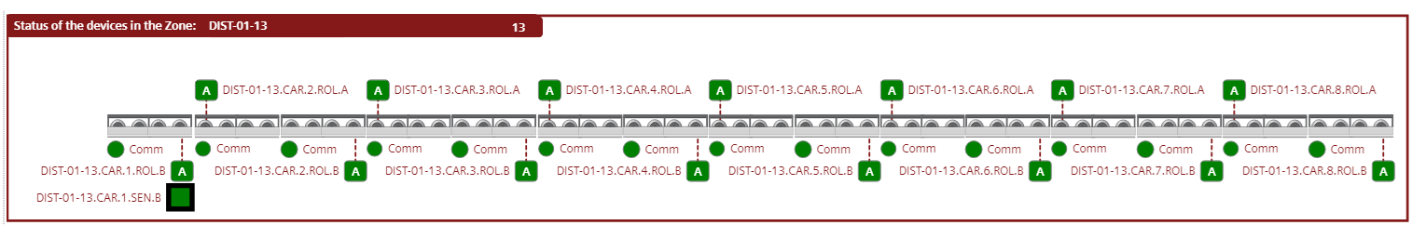
Figure 8. HMI Sensors Finger 3 DIST-01-13 (Lane 1).
The following figure shows the sensors that are located at the end of the lane that functions as ZPA.

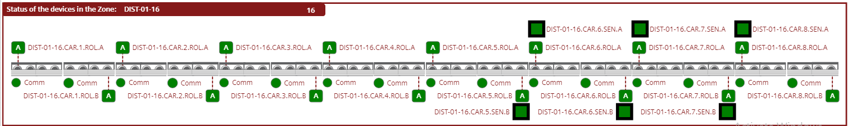
Figure 9. HMI Sensors Finger 3 DIST-01-16 (Lane 1).

Conveyor A (Lane 2) Devices.

Conveyor A is one of the longest lanes and features a large number of distribution panels and control cards. It includes distribution boards DIST-02-01 through DIST-01-12, as illustrated in the following figure. The control power on the cards in this section was implemented from the RIO 2 distribution board.

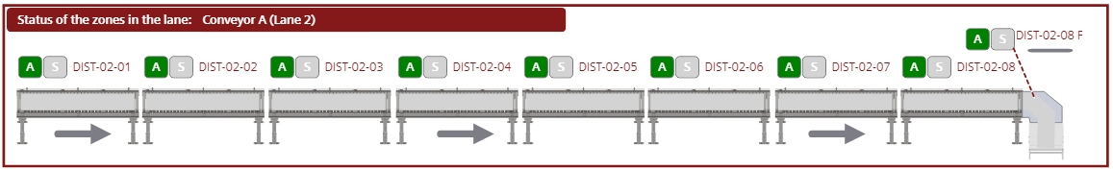
Figure 10. General composition of the Conveyor A (Lane 2).
The following Table shows the distribution boards, cards and motors activated for the operation of this lane.

DB ID | Card ID | Roller ID's
DIST-02-01 | DIST-02-01.CAR.1 | DIST-02-01.CAR.1.ROL.A
 |  | DIST-02-01.CAR.1.ROL.B
 | DIST-02-01.CAR.2 | DIST-02-01.CAR.2.ROL.A
 |  | DIST-02-01.CAR.2.ROL.B
 | DIST-02-01.CAR.3 | DIST-02-01.CAR.3.ROL.A
 |  | DIST-02-01.CAR.3.ROL.B
 | DIST-02-01.CAR.4 | DIST-02-01.CAR.4.ROL.A
 |  | DIST-02-01.CAR.4.ROL.B
 | DIST-02-01.CAR.5 | DIST-02-01.CAR.5.ROL.A
 |  | DIST-02-01.CAR.5.ROL.B
 | DIST-02-01.CAR.6 | DIST-02-01.CAR.6.ROL.A
 |  | DIST-02-01.CAR.6.ROL.B
DIST-02-02 | DIST-02-02.CAR.1 | DIST-02-02.CAR.1.ROL.A
 |  | DIST-02-02.CAR.1.ROL.B
 | DIST-02-02.CAR.2 | DIST-02-02.CAR.2.ROL.A
 |  | DIST-02-02.CAR.2.ROL.B
 | DIST-02-02.CAR.3 | DIST-02-02.CAR.3.ROL.A
 |  | DIST-02-02.CAR.3.ROL.B
 | DIST-02-02.CAR.4 | DIST-02-02.CAR.4.ROL.A
 |  | DIST-02-02.CAR.4.ROL.B
 | DIST-02-02.CAR.5 | DIST-02-02.CAR.5.ROL.A
 |  | DIST-02-02.CAR.5.ROL.B
 | DIST-02-02.CAR.6 | DIST-02-02.CAR.6.ROL.A
 |  | DIST-02-02.CAR.6.ROL.B
 | DIST-02-02.CAR.7 | DIST-02-02.CAR.7.ROL.A
 |  | DIST-02-02.CAR.7.ROL.B

DB ID | Card ID | Roller ID's
DIST-02-02 | DIST-02-02.CAR.8 | DIST-02-02.CAR.8.ROL.A
 |  | DIST-02-02.CAR.8.ROL.B
DIST-02-03 | DIST-02-03.CAR.1 | DIST-02-03.CAR.1.ROL.A
 |  | DIST-02-03.CAR.1.ROL.B
 | DIST-02-03.CAR.2 | DIST-02-03.CAR.2.ROL.A
 |  | DIST-02-03.CAR.2.ROL.B
 | DIST-02-03.CAR.3 | DIST-02-03.CAR.3.ROL.A
 |  | DIST-02-03.CAR.3.ROL.B
 | DIST-02-03.CAR.4 | DIST-02-03.CAR.4.ROL.A
 |  | DIST-02-03.CAR.4.ROL.B
 | DIST-02-03.CAR.5 | DIST-02-03.CAR.5.ROL.A
 |  | DIST-02-03.CAR.5.ROL.B
 | DIST-02-03.CAR.6 | DIST-02-03.CAR.6.ROL.A
 |  | DIST-02-03.CAR.6.ROL.B
 | DIST-02-03.CAR.7 | DIST-02-03.CAR.7.ROL.A
 |  | DIST-02-03.CAR.7.ROL.B
 | DIST-02-03.CAR.8 | DIST-02-03.CAR.8.ROL.A
 |  | Disabled
DIST-02-04 | DIST-02-04.CAR.1 | DIST-02-04.CAR.1.ROL.A
 |  | DIST-02-04.CAR.1.ROL.B
 | DIST-02-04.CAR.2 | DIST-02-04.CAR.2.ROL.A
 |  | DIST-02-04.CAR.2.ROL.B
 | DIST-02-04.CAR.3 | DIST-02-04.CAR.3.ROL.A
 |  | DIST-02-04.CAR.3.ROL.B

DB ID | Card ID | Roller ID's
DIST-02-04 | DIST-02-04.CAR.4 | DIST-02-04.CAR.4.ROL.A
 |  | DIST-02-04.CAR.4.ROL.B
 | DIST-02-04.CAR.5 | DIST-02-04.CAR.5.ROL.A
 |  | DIST-02-04.CAR.5.ROL.B
 | DIST-02-04.CAR.6 | DIST-02-04.CAR.6.ROL.A
 |  | DIST-02-04.CAR.6.ROL.B
 | DIST-02-04.CAR.7 | DIST-02-04.CAR.7.ROL.A
 |  | DIST-02-04.CAR.7.ROL.B
 | DIST-02-04.CAR.8 | DIST-02-04.CAR.8.ROL.A
 |  | DIST-02-04.CAR.8.ROL.B
DIST-02-05 | DIST-02-05.CAR.1 | DIST-02-05.CAR.1.ROL.A
 |  | DIST-02-05.CAR.1.ROL.B
 | DIST-02-05.CAR.2 | DIST-02-05.CAR.2.ROL.A
 |  | DIST-02-05.CAR.2.ROL.B
 | DIST-02-05.CAR.3 | DIST-02-05.CAR.3.ROL.A
 |  | DIST-02-05.CAR.3.ROL.B
 | DIST-02-05.CAR.4 | DIST-02-05.CAR.4.ROL.A
 |  | DIST-02-05.CAR.4.ROL.B
 | DIST-02-05.CAR.5 | DIST-02-05.CAR.5.ROL.A
 |  | DIST-02-05.CAR.5.ROL.B
 | DIST-02-05.CAR.6 | DIST-02-05.CAR.6.ROL.A
 |  | DIST-02-05.CAR.6.ROL.B
 | DIST-02-05.CAR.7 | DIST-02-05.CAR.7.ROL.A
 |  | DIST-02-05.CAR.7.ROL.B
 | DIST-02-05.CAR.8 | DIST-02-05.CAR.8.ROL.A
 |  | DIST-02-05.CAR.8.ROL.B
DIST-02-06 | DIST-02-06.CAR.1 | DIST-02-06.CAR.1.ROL.A
 |  | DIST-02-06.CAR.1.ROL.B
 | DIST-02-06.CAR.2 | DIST-02-06.CAR.2.ROL.A
 |  | DIST-02-06.CAR.2.ROL.B
 | DIST-02-06.CAR.3 | DIST-02-06.CAR.3.ROL.A
 |  | DIST-02-06.CAR.3.ROL.B
 | DIST-02-06.CAR.4 | DIST-02-06.CAR.4.ROL.A
 |  | DIST-02-06.CAR.4.ROL.B
 | DIST-02-06.CAR.5 | DIST-02-06.CAR.5.ROL.A
 |  | DIST-02-06.CAR.5.ROL.B
 | DIST-02-06.CAR.6 | DIST-02-06.CAR.6.ROL.A
 |  | DIST-02-06.CAR.6.ROL.B

DB ID | Card ID | Roller ID's
DIST-02-06 | DIST-02-06.CAR.7 | DIST-02-06.CAR.7.ROL.A
 |  | DIST-02-06.CAR.7.ROL.B
 | DIST-02-06.CAR.8 | DIST-02-06.CAR.8.ROL.A
 |  | DIST-02-06.CAR.8.ROL.B
DIST-02-07 | DIST-02-07.CAR.1 | DIST-02-07.CAR.1.ROL.A
 |  | DIST-02-07.CAR.1.ROL.B
 | DIST-02-07.CAR.2 | DIST-02-07.CAR.2.ROL.A
 |  | DIST-02-07.CAR.2.ROL.B
 | DIST-02-07.CAR.3 | DIST-02-07.CAR.3.ROL.A
 |  | DIST-02-07.CAR.3.ROL.B
 | DIST-02-07.CAR.4 | DIST-02-07.CAR.4.ROL.A
 |  | DIST-02-07.CAR.4.ROL.B
 | DIST-02-07.CAR.5 | DIST-02-07.CAR.5.ROL.A
 |  | DIST-02-07.CAR.5.ROL.B
 | DIST-02-07.CAR.6 | DIST-02-07.CAR.6.ROL.A
 |  | DIST-02-07.CAR.6.ROL.B
 | DIST-02-07.CAR.7 | DIST-02-07.CAR.7.ROL.A
 |  | DIST-02-07.CAR.7.ROL.B
 | DIST-02-07.CAR.8 | DIST-02-07.CAR.8.ROL.A
 |  | DIST-02-07.CAR.8.ROL.B
DIST-02-08 | DIST-02-08.CAR.1 | DIST-02-08.CAR.1.ROL.A
 |  | DIST-02-08.CAR.1.ROL.B
 | DIST-02-08.CAR.2 | DIST-02-08.CAR.2.ROL.A
 |  | DIST-02-08.CAR.2.ROL.B
 | DIST-02-08.CAR.3 | DIST-02-08.CAR.3.ROL.A
 |  | DIST-02-08.CAR.3.ROL.B
 | DIST-02-08.CAR.4 | DIST-02-08.CAR.4.ROL.A
 |  | DIST-02-08.CAR.4.ROL.B
 | DIST-02-08.CAR.5 | DIST-02-08.CAR.5.ROL.A
 |  | DIST-02-08.CAR.5.ROL.B
 | DIST-02-08.CAR.6 | DIST-02-08.CAR.6.ROL.A
 |  | DIST-02-08.CAR.6.ROL.B
 | DIST-02-08.CAR.7 | DIST-02-08.CAR.7.ROL.A
 |  | Disabled
 | DIST-02-08.CAR.8 | DIST-02-08.CAR.8.ROL.A
 | Interroll card | DIST-02-08.CAR.8.ROL.B
 | Interroll card | DIST-02-08.CAR.8.ROL.C

In this section, only one sensor was implemented at the curve or departure of the lane. The system determines the downstream state, checking if the finger is stopped or if the product flow direction is opposite. When a box is detected by this sensor, the lane will stop to prevent collisions between the transported products. The following figure and table show the sensor described above.

DB ID | Card ID | Sensor ID's
DIST-02-08 | DIST-02-08.CAR.8 | DIST-02-08.CAR.8.SEN.A
 |  | Disabled

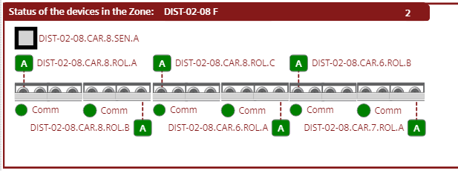
Figure 11. HMI Sensors Conveyor A (Lane 2).

Finger 1 (Lane 2) Devices.

Once the unit transported by Conveyor A leaves this lane, it enters Finger 1, where it is transported and received by the operator. This lane consists of distribution boards DIST-02-09 through DIST-02-12, as illustrated in the following figure. The control power on the cards in this section was implemented from the RIO 2 distribution board.

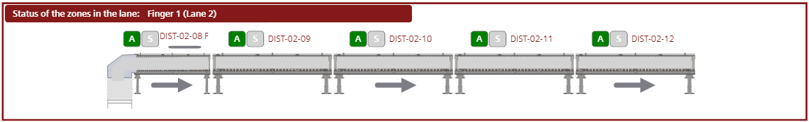
Figure 12. General composition of the Finger 3 (Lane 1).
The following Table shows the distribution boards, cards and motors activated for the operation of this lane.

DB ID | Card ID | Roller ID's
DIST-02-09 | DIST-02-09.CAR.1 | DIST-02-09.CAR.1.ROL.A
 |  | DIST-02-09.CAR.1.ROL.B
 | DIST-02-09.CAR.2 | DIST-02-09.CAR.2.ROL.A
 |  | DIST-02-09.CAR.2.ROL.B
 | DIST-02-09.CAR.3 | DIST-02-09.CAR.3.ROL.A
 |  | DIST-02-09.CAR.3.ROL.B
 | DIST-02-09.CAR.4 | DIST-02-09.CAR.4.ROL.A
 |  | DIST-02-09.CAR.4.ROL.B
 | DIST-02-09.CAR.5 | DIST-02-09.CAR.5.ROL.A
 |  | DIST-02-09.CAR.5.ROL.B
 | DIST-02-09.CAR.6 | DIST-02-09.CAR.6.ROL.A
 |  | DIST-02-09.CAR.6.ROL.B
 | DIST-02-09.CAR.7 | DIST-02-09.CAR.7.ROL.A
 |  | DIST-02-09.CAR.7.ROL.B
 | DIST-02-09.CAR.8 | DIST-02-09.CAR.8.ROL.A
 |  | DIST-02-09.CAR.8.ROL.B
DIST-02-10 | DIST-02-10.CAR.1 | DIST-02-10.CAR.1.ROL.A
 |  | DIST-02-10.CAR.1.ROL.B
 | DIST-02-10.CAR.2 | DIST-02-10.CAR.2.ROL.A
 |  | DIST-02-10.CAR.2.ROL.B
 | DIST-02-10.CAR.3 | DIST-02-10.CAR.3.ROL.A
 |  | DIST-02-10.CAR.3.ROL.B
 | DIST-02-10.CAR.4 | DIST-02-10.CAR.4.ROL.A
 |  | DIST-02-10.CAR.4.ROL.B
 | DIST-02-10.CAR.5 | DIST-02-10.CAR.5.ROL.A

DB ID | Card ID | Roller ID's
DIST-02-10 | DIST-02-10.CAR.5 | DIST-02-10.CAR.5.ROL.B
 | DIST-02-10.CAR.6 | DIST-02-10.CAR.6.ROL.A
 |  | DIST-02-10.CAR.6.ROL.B
 | DIST-02-10.CAR.7 | DIST-02-10.CAR.7.ROL.A
 |  | DIST-02-10.CAR.7.ROL.B
 | DIST-02-10.CAR.8 | DIST-02-10.CAR.8.ROL.A
 |  | DIST-02-10.CAR.8.ROL.B
DIST-02-11 | DIST-02-11.CAR.1 | DIST-02-11.CAR.1.ROL.A
 |  | DIST-02-11.CAR.1.ROL.B
 | DIST-02-11.CAR.2 | DIST-02-11.CAR.2.ROL.A
 |  | DIST-02-11.CAR.2.ROL.B
 | DIST-02-11.CAR.3 | DIST-02-11.CAR.3.ROL.A
 |  | DIST-02-11.CAR.3.ROL.B
 | DIST-02-11.CAR.4 | DIST-02-11.CAR.4.ROL.A
 |  | DIST-02-11.CAR.4.ROL.B
 | DIST-02-11.CAR.5 | DIST-02-11.CAR.5.ROL.A
 |  | DIST-02-11.CAR.5.ROL.B
 | DIST-02-11.CAR.6 | DIST-02-11.CAR.6.ROL.A
 |  | DIST-02-11.CAR.6.ROL.B
 | DIST-02-11.CAR.7 | DIST-02-11.CAR.7.ROL.A
 |  | DIST-02-11.CAR.7.ROL.B
 | DIST-02-11.CAR.8 | DIST-02-11.CAR.8.ROL.A
 |  | DIST-02-11.CAR.8.ROL.B
DIST-02-12 | DIST-02-12.CAR.1 | DIST-02-12.CAR.1.ROL.A
 |  | DIST-02-12.CAR.1.ROL.B

DB ID | Card ID | Roller ID's
DIST-02-12 | DIST-02-12.CAR.2 | DIST-02-12.CAR.2.ROL.A
 |  | DIST-02-12.CAR.2.ROL.B
 | DIST-02-12.CAR.3 | DIST-02-12.CAR.3.ROL.A
 |  | DIST-02-12.CAR.3.ROL.B
 | DIST-02-12.CAR.4 | DIST-02-12.CAR.4.ROL.A
 |  | DIST-02-12.CAR.4.ROL.B
 | DIST-02-12.CAR.5 | DIST-02-12.CAR.5.ROL.A
 |  | DIST-02-12.CAR.5.ROL.B
 | DIST-02-12.CAR.6 | DIST-02-12.CAR.6.ROL.A
 |  | DIST-02-12.CAR.6.ROL.B
 | DIST-02-12.CAR.7 | DIST-02-12.CAR.7.ROL.A
 |  | DIST-02-12.CAR.7.ROL.B
 | DIST-02-12.CAR.8 | DIST-02-12.CAR.8.ROL.A
 |  | DIST-02-12.CAR.8.ROL.B

This conveyor acts as a single conveyor and behaves the same way a BUR conveyor would, except for when the finger has filled up. Finger 1 has the ability to convert to a ZPA style conveyor. The sensors involved in this section are shown in the following table and figure.

DB ID | Card ID | Sensor ID's
DIST-02-09 | DIST-02-09.CAR.1 | DIST-02-09.CAR.1.SEN.A
 |  | Disabled
DIST-02-12 | DIST-02-12.CAR.5 | Disabled
 |  | DIST-02-12.CAR.5.SEN.B
 | DIST-02-12.CAR.6 | DIST-02-12.CAR.6.SEN.A
 |  | DIST-02-12.CAR.6.SEN.B
 | DIST-02-12.CAR.7 | DIST-02-12.CAR.7.SEN.A
 |  | DIST-02-12.CAR.7.SEN.B
 | DIST-02-12.CAR.8 | DIST-02-12.CAR.8.SEN.A
 |  | Disabled

The next sensor shown in the figure behaves like ZPA but when the transport flow direction is changed this sensor stops the Finger to avoid collisions between boxes or units.
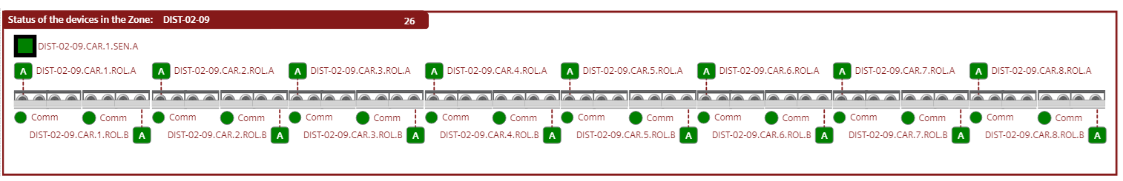
Figure 13. HMI Sensors Finger 1 DIST-02-09 (Lane 2).
The following figure shows the sensors that are located at the end of the lane that functions as ZPA.

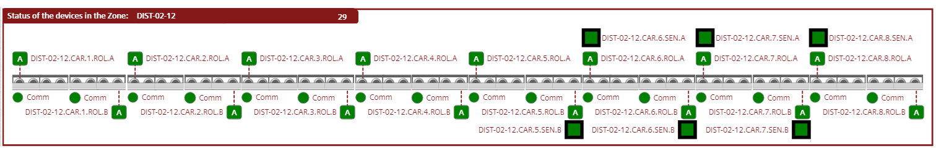
Figure 14. HMI Sensors Finger 1 DIST-02-12 (Lane 2).

Conveyor C (Lane 3) Devices.

To transport the boxes or units from Conveyor B to Finger 2, they must pass through Conveyor C, which consists of two distribution boards, DIST-03-01 and DIST-03-02, along with the control cards that make up the lane, as illustrated in the following figure (Included in these distribution boards are the cards and motors that control the transfer rollers between Conveyor B and Conveyor C). The control power for the cards in this section is supplied from the RIO 1 distribution board.

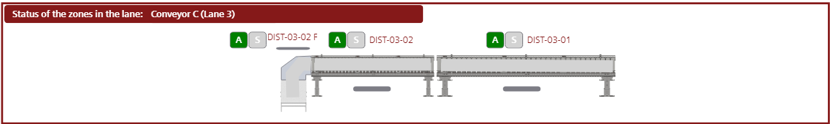
Figure 15. General composition of the Conveyor C (Lane 3).

The following Table shows the distribution boards, cards and motors activated for the operation of this lane.

DB ID | Card ID | Roller ID's
DIST-03-01 | DIST-03-01.CAR.1 | DIST-03-01.CAR.1.ROL.A
 |  | DIST-03-01.CAR.1.ROL.B
 | DIST-03-01.CAR.2 | DIST-03-01.CAR.2.ROL.A
 |  | DIST-03-01.CAR.2.ROL.B
 | DIST-03-01.CAR.3 | DIST-03-01.CAR.3.ROL.A
 |  | DIST-03-01.CAR.3.ROL.B
 | DIST-03-01.CAR.4 | DIST-03-01.CAR.4.ROL.A
 |  | DIST-03-01.CAR.4.ROL.B
 | DIST-03-01.CAR.5 | DIST-03-01.CAR.5.ROL.A
 |  | DIST-03-01.CAR.5.ROL.B
 | DIST-03-01.CAR.6 | DIST-03-01.CAR.6.ROL.A
 |  | DIST-03-01.CAR.6.ROL.B
 | DIST-03-01.CAR.7 | DIST-03-01.CAR.7.ROL.A
 |  | DIST-03-01.CAR.7.ROL.B
 | DIST-03-01.CAR.8 | DIST-03-01.CAR.8.ROL.A
 |  | DIST-03-01.CAR.8.ROL.B

DB ID | Card ID | Roller ID's
DIST-03-02 | DIST-03-02.CAR.1 | DIST-03-02.CAR.1.ROL.A
 |  | DIST-03-02.CAR.1.ROL.B
 | DIST-03-02.CAR.2 | DIST-03-02.CAR.2.ROL.A
 |  | DIST-03-02.CAR.2.ROL.B
 | DIST-03-02.CAR.3 | DIST-03-02.CAR.3.ROL.A
 |  | DIST-03-02.CAR.3.ROL.B
 | DIST-03-02.CAR.4 | DIST-03-02.CAR.4.ROL.A
 |  | DIST-03-02.CAR.4.ROL.B
 | DIST-03-02.CAR.5 | DIST-03-02.CAR.5.ROL.A
 |  | DIST-03-02.CAR.5.ROL.B
 | DIST-03-02.CAR.6 | DIST-03-02.CAR.6.ROL.A
 | Interroll card | DIST-03-02.CAR.6.ROL.B
 | Interroll card | DIST-03-02.CAR.6.ROL.C

In this section, only one sensor was implemented at the curve or departure of the lane. The system determines the downstream state, checking if the finger is stopped or if the product flow direction is opposite. When a box is detected by this sensor, the lane will stop to prevent collisions between the transported products. The following figure and table show the sensor described above.

DB ID | Card ID | Sensor ID's
DIST-03-02 | DIST-03-02.CAR.6 | DIST-03-02.CAR.6.SEN.A
 |  | Disabled

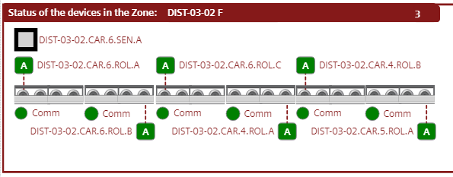
Figure 16. HMI Sensors Conveyor C (Lane 3).

Finger 2 (Lane 3) Devices.

Once the unit transported by Conveyor C leaves this lane, it enters Finger 2, where it is transported and received by the operator. This lane consists of distribution boards DIST-03-03 through DIST-03-06, as illustrated in the following figure. The control power on the cards in this section was implemented from the RIO 1 distribution board.

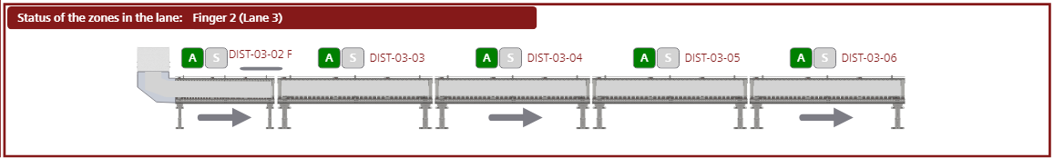
Figure 17. General composition of the Finger 3 (Lane 1).
The following Table shows the distribution boards, cards and motors activated for the operation of this lane.

DB ID | Card ID | Roller ID's
DIST-03-03 | DIST-03-03.CAR.1 | DIST-03-03.CAR.1.ROL.A
 |  | DIST-03-03.CAR.1.ROL.B
 | DIST-03-03.CAR.2 | DIST-03-03.CAR.2.ROL.A
 |  | DIST-03-03.CAR.2.ROL.B
 | DIST-03-03.CAR.3 | DIST-03-03.CAR.3.ROL.A
 |  | DIST-03-03.CAR.3.ROL.B
 | DIST-03-03.CAR.4 | DIST-03-03.CAR.4.ROL.A
 |  | DIST-03-03.CAR.4.ROL.B
 | DIST-03-03.CAR.5 | DIST-03-03.CAR.5.ROL.A
 |  | DIST-03-03.CAR.5.ROL.B
 | DIST-03-03.CAR.6 | DIST-03-03.CAR.6.ROL.A
 |  | DIST-03-03.CAR.6.ROL.B
 | DIST-03-03.CAR.7 | DIST-03-03.CAR.7.ROL.A
 |  | DIST-03-03.CAR.7.ROL.B
 | DIST-03-03.CAR.8 | DIST-03-03.CAR.8.ROL.A
 |  | DIST-03-03.CAR.8.ROL.B
DIST-03-04 | DIST-03-04.CAR.1 | DIST-03-04.CAR.1.ROL.A
 |  | DIST-03-04.CAR.1.ROL.B
 | DIST-03-04.CAR.2 | DIST-03-04.CAR.2.ROL.A
 |  | DIST-03-04.CAR.2.ROL.B
 | DIST-03-04.CAR.3 | DIST-03-04.CAR.3.ROL.A
 |  | DIST-03-04.CAR.3.ROL.B
 | DIST-03-04.CAR.4 | DIST-03-04.CAR.4.ROL.A
 |  | DIST-03-04.CAR.4.ROL.B
 | DIST-03-04.CAR.5 | DIST-03-04.CAR.5.ROL.A

DB ID | Card ID | Roller ID's
DIST-03-04 | DIST-03-04.CAR.5 | DIST-03-04.CAR.5.ROL.B
 | DIST-03-04.CAR.6 | DIST-03-04.CAR.6.ROL.A
 |  | DIST-03-04.CAR.6.ROL.B
 | DIST-03-04.CAR.7 | DIST-03-04.CAR.7.ROL.A
 |  | DIST-03-04.CAR.7.ROL.B
 | DIST-03-04.CAR.8 | DIST-03-04.CAR.8.ROL.A
 |  | DIST-03-04.CAR.8.ROL.B
DIST-03-05 | DIST-03-05.CAR.1 | DIST-03-05.CAR.1.ROL.A
 |  | DIST-03-05.CAR.1.ROL.B
 | DIST-03-05.CAR.2 | DIST-03-05.CAR.2.ROL.A
 |  | DIST-03-05.CAR.2.ROL.B
 | DIST-03-05.CAR.3 | DIST-03-05.CAR.3.ROL.A
 |  | DIST-03-05.CAR.3.ROL.B
 | DIST-03-05.CAR.4 | DIST-03-05.CAR.4.ROL.A
 |  | DIST-03-05.CAR.4.ROL.B
 | DIST-03-05.CAR.5 | DIST-03-05.CAR.5.ROL.A
 |  | DIST-03-05.CAR.5.ROL.B
 | DIST-03-05.CAR.6 | DIST-03-05.CAR.6.ROL.A
 |  | DIST-03-05.CAR.6.ROL.B
 | DIST-03-05.CAR.7 | DIST-03-05.CAR.7.ROL.A
 |  | DIST-03-05.CAR.7.ROL.B
 | DIST-03-05.CAR.8 | DIST-03-05.CAR.8.ROL.A
 |  | DIST-03-05.CAR.8.ROL.B
DIST-03-06 | DIST-03-06.CAR.1 | DIST-03-06.CAR.1.ROL.A
 |  | DIST-03-06.CAR.1.ROL.B

DB ID | Card ID | Roller ID's
DIST-03-06 | DIST-03-06.CAR.2 | DIST-03-06.CAR.2.ROL.A
 |  | DIST-03-06.CAR.2.ROL.B
 | DIST-03-06.CAR.3 | DIST-03-06.CAR.3.ROL.A
 |  | DIST-03-06.CAR.3.ROL.B
 | DIST-03-06.CAR.4 | DIST-03-06.CAR.4.ROL.A
 |  | DIST-03-06.CAR.4.ROL.B
 | DIST-03-06.CAR.5 | DIST-03-06.CAR.5.ROL.A
 |  | DIST-03-06.CAR.5.ROL.B
 | DIST-03-06.CAR.6 | DIST-03-06.CAR.6.ROL.A
 |  | DIST-03-06.CAR.6.ROL.B
 | DIST-03-06.CAR.7 | DIST-03-06.CAR.7.ROL.A
 |  | DIST-03-06.CAR.7.ROL.B
 | DIST-03-06.CAR.8 | DIST-03-06.CAR.8.ROL.A
 |  | DIST-03-06.CAR.8.ROL.B

This conveyor acts as a single conveyor and behaves the same way a BUR conveyor would, except for when the finger has filled up. Finger 2 has the ability to convert to a ZPA style conveyor. The sensors involved in this section are shown in the following table and figure.

DB ID | Card ID | Sensor ID's
DIST-03-03 | DIST-03-03.CAR.1 | DIST-03-03.CAR.1.SEN.A
 |  | Disabled
DIST-03-06 | DIST-03-06.CAR.5 | Disabled
 |  | DIST-03-06.CAR.5.SEN.B
 | DIST-03-06.CAR.6 | DIST-03-06.CAR.6.SEN.A
 |  | DIST-03-06.CAR.6.SEN.B
 | DIST-03-06.CAR.7 | DIST-03-06.CAR.7.SEN.A
 |  | DIST-03-06.CAR.7.SEN.B
 | DIST-03-06.CAR.8 | DIST-03-06.CAR.8.SEN.A
 |  | Disabled

The next sensor shown in the figure behaves like ZPA but when the transport flow direction is changed this sensor stops the Finger to avoid collisions between boxes or units.
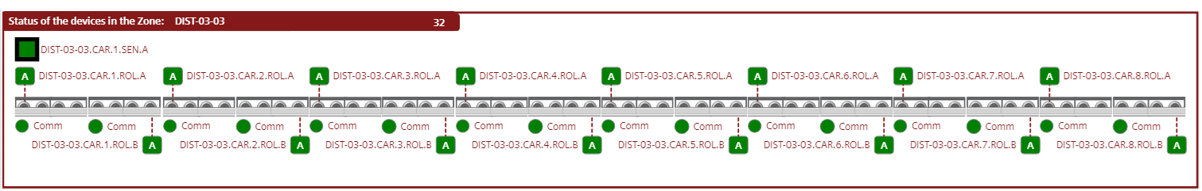
Figure 18. HMI Sensors Finger 2 DIST-03-03 (Lane 3).
The following figure shows the sensors that are located at the end of the lane that functions as ZPA.

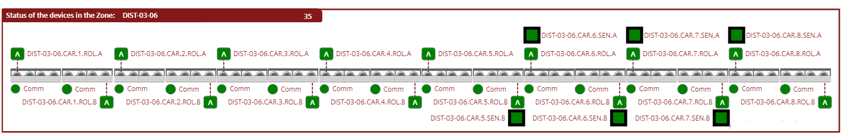
Figure 19. HMI Sensors Finger 2 DIST-03-06 (Lane 3).

Induct table 1 (Lane 4) Devices.

The induction lane functions to transport and introduce units to Conveyors A and B. It consists of the DIST-04-01 distribution board, as shown in the following table. The control power on the cards in this section was implemented from the RIO 2 distribution board.

The following Table shows the distribution boards, cards and motors activated for the operation of this lane.

DB ID | Card ID | Roller ID's
DIST-04-01 | DIST-04-01.CAR.1 | DIST-04-01.CAR.1.ROL.A
 |  | DIST-04-01.CAR.1.ROL.B
 | DIST-04-01.CAR.2 | DIST-04-01.CAR.2.ROL.A
 |  | DIST-04-01.CAR.2.ROL.B
 | DIST-04-01.CAR.3 | DIST-04-01.CAR.3.ROL.A
 |  | DIST-04-01.CAR.3.ROL.B
 | DIST-04-01.CAR.4 | DIST-04-01.CAR.4.ROL.A
 |  | DIST-04-01.CAR.4.ROL.B
 | DIST-04-01.CAR.5 | DIST-04-01.CAR.5.ROL.A
 |  | DIST-04-01.CAR.5.ROL.B

The induction lane is equipped with a photoelectric sensor at its end. If the sensor is blocked for more than 5 seconds, the table will stop and will only restart once the sensor is cleared. If the system is in energy-saving mode, it will restart both the induction lane and the downstream lanes. The following table show the sensor in the HMI.

DB ID | Card ID | Sensor ID's
DIST-04-01 | DIST-04-01.CAR.1 | DIST-04-01.CAR.1.SEN.A
 |  | Disabled

Takeaway conveyor 1 (Lane 5) Devices.

The takeaway conveyor is designed to transport and return units to the start of the induction table if a unit needs to be rejected. This lane consists of the DIST-05-01 distribution board, as shown in the following table. The control power on the cards in this section was implemented from the RIO 2 distribution board.

The following Table shows the distribution boards, cards and motors activated for the operation of this lane.

DB ID | Card ID | Roller ID's
DIST-05-01 | DIST-05-01.CAR.1 | Disabled
 |  | DIST-05-01.CAR.1.ROL.B
 | DIST-05-01.CAR.2 | DIST-05-01.CAR.2.ROL.A
 |  | DIST-05-01.CAR.2.ROL.B
 | DIST-05-01.CAR.3 | DIST-05-01.CAR.3.ROL.A
 |  | DIST-05-01.CAR.3.ROL.B
 | DIST-05-01.CAR.4 | DIST-05-01.CAR.4.ROL.A
 |  | DIST-05-01.CAR.4.ROL.B
 | DIST-05-01.CAR.5 | DIST-05-01.CAR.5.ROL.A
 |  | DIST-05-01.CAR.5.ROL.B
 | DIST-05-01.CAR.6 | DIST-05-01.CAR.6.ROL.A
 |  | DIST-05-01.CAR.6.ROL.B
 | DIST-05-01.CAR.7 | DIST-05-01.CAR.7.ROL.A
 |  | DIST-05-01.CAR.7.ROL.B
 | DIST-05-01.CAR.8 | DIST-05-01.CAR.8.ROL.A
 |  | DIST-05-01.CAR.8.ROL.B

This conveyor acts as a single conveyor and behaves the same way a BUR conveyor would, except for when the Takeaway conveyor has filled up. Takeaway conveyor has the ability to convert to a ZPA style conveyor. The sensors involved in this section are shown in the following table.

DB ID | Card ID | Sensor ID's
DIST-05-01 | DIST-05-01.CAR.4 | DIST-05-01.CAR.4.SEN.A
 |  | DIST-05-01.CAR.4.SEN.B
 | DIST-05-01.CAR.5 | DIST-05-01.CAR.5.SEN.A
 |  | DIST-05-01.CAR.5.SEN.B
 | DIST-05-01.CAR.6 | DIST-05-01.CAR.6.SEN.A
 |  | DIST-05-01.CAR.6.SEN.B
 | DIST-05-01.CAR.7 | DIST-05-01.CAR.7.SEN.A
 |  | DIST-05-01.CAR.7.SEN.B
 | DIST-05-01.CAR.8 | DIST-05-01.CAR.8.SEN.A
 |  | DIST-05-01.CAR.8.SEN.B

Induct table 2 (Lane 6) Devices.

The induction lane functions to transport and introduce units to Conveyors A and B. It consists of the DIST-06-01 distribution board, as shown in the following table. The control power on the cards in this section was implemented from the RIO 2 distribution board.

The following Table shows the distribution boards, cards and motors activated for the operation of this lane.

DB ID | Card ID | Roller ID's
DIST-06-01 | DIST-06-01.CAR.1 | DIST-06-01.CAR.1.ROL.A
 |  | DIST-06-01.CAR.1.ROL.B
 | DIST-06-01.CAR.2 | DIST-06-01.CAR.2.ROL.A
 |  | DIST-06-01.CAR.2.ROL.B
 | DIST-06-01.CAR.3 | DIST-06-01.CAR.3.ROL.A
 |  | DIST-06-01.CAR.3.ROL.B
 | DIST-06-01.CAR.4 | DIST-06-01.CAR.4.ROL.A
 |  | DIST-06-01.CAR.4.ROL.B
 | DIST-06-01.CAR.5 | DIST-06-01.CAR.5.ROL.A
 |  | DIST-06-01.CAR.5.ROL.B

The induction lane is equipped with a photoelectric sensor at its end. If the sensor is blocked for more than 5 seconds, the table will stop and will only restart once the sensor is cleared. If the system is in energy-saving mode, it will restart both the induction lane and the downstream lanes. The following table show the sensor in the HMI.

DB ID | Card ID | Sensor ID's
DIST-06-01 | DIST-06-01.CAR.1 | DIST-06-01.CAR.1.SEN.A
 |  | Disabled

Figure 20. HMI Sensors Induct table 2 DIST-06-01 (Lane 6).

Induct table 3 (Lane 7) Devices.

The induction lane functions to transport and introduce units to Conveyors A and B. It consists of the DIST-07-01 distribution board, as shown in the following table. The control power on the cards in this section was implemented from the RIO 2 distribution board.

The following Table shows the distribution boards, cards and motors activated for the operation of this lane.

DB ID | Card ID | Roller ID's
DIST-07-01 | DIST-07-01.CAR.1 | DIST-07-01.CAR.1.ROL.A
 |  | DIST-07-01.CAR.1.ROL.B
 | DIST-07-01.CAR.2 | DIST-07-01.CAR.2.ROL.A
 |  | DIST-07-01.CAR.2.ROL.B
 | DIST-07-01.CAR.3 | DIST-07-01.CAR.3.ROL.A
 |  | DIST-07-01.CAR.3.ROL.B
 | DIST-07-01.CAR.4 | DIST-07-01.CAR.4.ROL.A
 |  | DIST-07-01.CAR.4.ROL.B
 | DIST-07-01.CAR.5 | DIST-07-01.CAR.5.ROL.A
 |  | DIST-07-01.CAR.5.ROL.B

The induction lane is equipped with a photoelectric sensor at its end. If the sensor is blocked for more than 5 seconds, the table will stop and will only restart once the sensor is cleared. If the system is in energy-saving mode, it will restart both the induction lane and the downstream lanes. The following table show the sensor in the HMI.

DB ID | Card ID | Sensor ID's
DIST-07-01 | DIST-07-01.CAR.1 | DIST-07-01.CAR.1.SEN.A
 |  | Disabled

Induct table 4 (Lane 8) Devices.

The induction lane functions to transport and introduce units to Conveyors A and B. It consists of the DIST-08-01 distribution board, as shown in the following table. The control power on the cards in this section was implemented from the RIO 2 distribution board.

The following Table shows the distribution boards, cards and motors activated for the operation of this lane.

DB ID | Card ID | Roller ID's
DIST-08-01 | DIST-08-01.CAR.1 | DIST-08-01.CAR.1.ROL.A
 |  | DIST-08-01.CAR.1.ROL.B
 | DIST-08-01.CAR.2 | DIST-08-01.CAR.2.ROL.A
 |  | DIST-08-01.CAR.2.ROL.B
 | DIST-08-01.CAR.3 | DIST-08-01.CAR.3.ROL.A
 |  | DIST-08-01.CAR.3.ROL.B
 | DIST-08-01.CAR.4 | DIST-08-01.CAR.4.ROL.A
 |  | DIST-08-01.CAR.4.ROL.B
 | DIST-08-01.CAR.5 | DIST-08-01.CAR.5.ROL.A
 |  | DIST-08-01.CAR.5.ROL.B

The induction lane is equipped with a photoelectric sensor at its end. If the sensor is blocked for more than 5 seconds, the table will stop and will only restart once the sensor is cleared. If the system is in energy-saving mode, it will restart both the induction lane and the downstream lanes. The following table show the sensor in the HMI.

DB ID | Card ID | Sensor ID's
DIST-08-01 | DIST-08-01.CAR.1 | DIST-08-01.CAR.1.SEN.A
 |  | Disabled

Takeaway conveyor 2 (Lane 9) Devices.

The takeaway conveyor is designed to transport and return units to the start of the induction table if a unit needs to be rejected. This lane consists of the DIST-09-01 distribution board, as shown in the following table. The control power on the cards in this section was implemented from the RIO 2 distribution board.

The following Table shows the distribution boards, cards and motors activated for the operation of this lane.

DB ID | Card ID | Roller ID's
DIST-09-01 | DIST-09-01.CAR.1 | Disabled
 |  | DIST-09-01.CAR.1.ROL.B
 | DIST-09-01.CAR.2 | DIST-09-01.CAR.2.ROL.A
 |  | DIST-09-01.CAR.2.ROL.B
 | DIST-09-01.CAR.3 | DIST-09-01.CAR.3.ROL.A
 |  | DIST-09-01.CAR.3.ROL.B
 | DIST-09-01.CAR.4 | DIST-09-01.CAR.4.ROL.A
 |  | DIST-09-01.CAR.4.ROL.B
 | DIST-09-01.CAR.5 | DIST-09-01.CAR.5.ROL.A
 |  | DIST-09-01.CAR.5.ROL.B
 | DIST-09-01.CAR.6 | DIST-09-01.CAR.6.ROL.A
 |  | DIST-09-01.CAR.6.ROL.B
 | DIST-09-01.CAR.7 | DIST-09-01.CAR.7.ROL.A
 |  | DIST-09-01.CAR.7.ROL.B
 | DIST-09-01.CAR.8 | DIST-09-01.CAR.8.ROL.A
 |  | DIST-09-01.CAR.8.ROL.B

This conveyor acts as a single conveyor and behaves the same way a BUR conveyor would, except for when the Takeaway conveyor has filled up. Takeaway conveyor has the ability to convert to a ZPA style conveyor. The sensors involved in this section are shown in the following table.

DB ID | Card ID | Sensor ID's
DIST-09-01 | DIST-09-01.CAR.4 | DIST-09-01.CAR.4.SEN.A
 |  | DIST-09-01.CAR.4.SEN.B
 | DIST-09-01.CAR.5 | DIST-09-01.CAR.5.SEN.A
 |  | DIST-09-01.CAR.5.SEN.B
 | DIST-09-01.CAR.6 | DIST-09-01.CAR.6.SEN.A
 |  | DIST-09-01.CAR.6.SEN.B
 | DIST-09-01.CAR.7 | DIST-09-01.CAR.7.SEN.A
 |  | DIST-09-01.CAR.7.SEN.B
 | DIST-09-01.CAR.8 | DIST-09-01.CAR.8.SEN.A
 |  | DIST-09-01.CAR.8.SEN.B

Induct table 5 (Lane 10) Devices.

The induction lane functions to transport and introduce units to Conveyors A and B. It consists of the DIST-10-01 distribution board, as shown in the following table. The control power on the cards in this section was implemented from the RIO 2 distribution board.

The following Table shows the distribution boards, cards and motors activated for the operation of this lane.

DB ID | Card ID | Roller ID's
DIST-10-01 | DIST-10-01.CAR.1 | DIST-10-01.CAR.1.ROL.A
 |  | DIST-10-01.CAR.1.ROL.B
 | DIST-10-01.CAR.2 | DIST-10-01.CAR.2.ROL.A
 |  | DIST-10-01.CAR.2.ROL.B
 | DIST-10-01.CAR.3 | DIST-10-01.CAR.3.ROL.A
 |  | DIST-10-01.CAR.3.ROL.B
 | DIST-10-01.CAR.4 | DIST-10-01.CAR.4.ROL.A
 |  | DIST-10-01.CAR.4.ROL.B
 | DIST-10-01.CAR.5 | DIST-10-01.CAR.5.ROL.A
 |  | DIST-10-01.CAR.5.ROL.B

The induction lane is equipped with a photoelectric sensor at its end. If the sensor is blocked for more than 5 seconds, the table will stop and will only restart once the sensor is cleared. If the system is in energy-saving mode, it will restart both the induction lane and the downstream lanes. The following table show the sensor in the HMI.

DB ID | Card ID | Sensor ID's
DIST-10-01 | DIST-10-01.CAR.1 | DIST-10-01.CAR.1.SEN.A
 |  | Disabled

Induct table 6 (Lane 11) Devices.

The induction lane functions to transport and introduce units to Conveyors A and B. It consists of the DIST-11-01 distribution board, as shown in the following table. The control power on the cards in this section was implemented from the RIO 2 distribution board.

The following Table shows the distribution boards, cards and motors activated for the operation of this lane.

DB ID | Card ID | Roller ID's
DIST-11-01 | DIST-11-01.CAR.1 | DIST-11-01.CAR.1.ROL.A
 |  | DIST-11-01.CAR.1.ROL.B
 | DIST-11-01.CAR.2 | DIST-11-01.CAR.2.ROL.A
 |  | DIST-11-01.CAR.2.ROL.B
 | DIST-11-01.CAR.3 | DIST-11-01.CAR.3.ROL.A
 |  | DIST-11-01.CAR.3.ROL.B
 | DIST-11-01.CAR.4 | DIST-11-01.CAR.4.ROL.A
 |  | DIST-11-01.CAR.4.ROL.B
 | DIST-11-01.CAR.5 | DIST-11-01.CAR.5.ROL.A
 |  | DIST-11-01.CAR.5.ROL.B

The induction lane is equipped with a photoelectric sensor at its end. If the sensor is blocked for more than 5 seconds, the table will stop and will only restart once the sensor is cleared. If the system is in energy-saving mode, it will restart both the induction lane and the downstream lanes. The following table show the sensor in the HMI.

DB ID | Card ID | Sensor ID's
DIST-11-01 | DIST-11-01.CAR.1 | DIST-11-01.CAR.1.SEN.A
 |  | Disabled

Takeaway conveyor 3 (Lane 12) Devices.

The takeaway conveyor is designed to transport and return units to the start of the induction table if a unit needs to be rejected. This lane consists of the DIST-09-01 distribution board, as shown in the following table. The control power on the cards in this section was implemented from the RIO 2 distribution board.

The following Table shows the distribution boards, cards and motors activated for the operation of this lane.

DB ID | Card ID | Roller ID's
DIST-12-01 | DIST-12-01.CAR.1 | Disabled
 |  | DIST-12-01.CAR.1.ROL.B
 | DIST-12-01.CAR.2 | DIST-12-01.CAR.2.ROL.A
 |  | DIST-12-01.CAR.2.ROL.B
 | DIST-12-01.CAR.3 | DIST-12-01.CAR.3.ROL.A
 |  | DIST-12-01.CAR.3.ROL.B
 | DIST-12-01.CAR.4 | DIST-12-01.CAR.4.ROL.A
 |  | DIST-12-01.CAR.4.ROL.B
 | DIST-12-01.CAR.5 | DIST-12-01.CAR.5.ROL.A
 |  | DIST-12-01.CAR.5.ROL.B
 | DIST-12-01.CAR.6 | DIST-12-01.CAR.6.ROL.A
 |  | DIST-12-01.CAR.6.ROL.B
 | DIST-12-01.CAR.7 | DIST-12-01.CAR.7.ROL.A
 |  | DIST-12-01.CAR.7.ROL.B
 | DIST-12-01.CAR.8 | DIST-12-01.CAR.8.ROL.A
 |  | DIST-12-01.CAR.8.ROL.B

This conveyor acts as a single conveyor and behaves the same way a BUR conveyor would, except for when the Takeaway conveyor has filled up. Takeaway conveyor has the ability to convert to a ZPA style conveyor. The sensors involved in this section are shown in the following table.

DB ID | Card ID | Sensor ID's
DIST-12-01 | DIST-12-01.CAR.4 | DIST-12-01.CAR.4.SEN.A
 |  | DIST-12-01.CAR.4.SEN.B
 | DIST-12-01.CAR.5 | DIST-12-01.CAR.5.SEN.A
 |  | DIST-12-01.CAR.5.SEN.B
 | DIST-12-01.CAR.6 | DIST-12-01.CAR.6.SEN.A
 |  | DIST-12-01.CAR.6.SEN.B
 | DIST-12-01.CAR.7 | DIST-12-01.CAR.7.SEN.A
 |  | DIST-12-01.CAR.7.SEN.B
 | DIST-12-01.CAR.8 | DIST-12-01.CAR.8.SEN.A
 |  | DIST-12-01.CAR.8.SEN.B

Induct table 7 (Lane 13) Devices.

The induction lane functions to transport and introduce units to Conveyors A and B. It consists of the DIST-13-01 distribution board, as shown in the following table. The control power on the cards in this section was implemented from the RIO 2 distribution board.

The following Table shows the distribution boards, cards and motors activated for the operation of this lane.

DB ID | Card ID | Roller ID's
DIST-13-01 | DIST-13-01.CAR.1 | DIST-13-01.CAR.1.ROL.A
 |  | DIST-13-01.CAR.1.ROL.B
 | DIST-13-01.CAR.2 | DIST-13-01.CAR.2.ROL.A
 |  | DIST-13-01.CAR.2.ROL.B
 | DIST-13-01.CAR.3 | DIST-13-01.CAR.3.ROL.A
 |  | DIST-13-01.CAR.3.ROL.B
 | DIST-13-01.CAR.4 | DIST-13-01.CAR.4.ROL.A
 |  | DIST-13-01.CAR.4.ROL.B
 | DIST-13-01.CAR.5 | DIST-13-01.CAR.5.ROL.A
 |  | DIST-13-01.CAR.5.ROL.B

The induction lane is equipped with a photoelectric sensor at its end. If the sensor is blocked for more than 5 seconds, the table will stop and will only restart once the sensor is cleared. If the system is in energy-saving mode, it will restart both the induction lane and the downstream lanes. The following table show the sensor in the HMI.

DB ID | Card ID | Sensor ID's
DIST-13-01 | DIST-13-01.CAR.1 | DIST-13-01.CAR.1.SEN.A
 |  | Disabled

Transfer Rollers (Section 14) Devices.
Conveyor B can be disabled. This can be actioned only from the central HMI. In normal operation (Conveyor B enabled), operators can manually push containers from Conveyor A to Conveyor B. This will be assisted by the powered transfer roller running in the direction of A to B. In the event that Conveyor B is disabled, the powered transfer roller will be running in the direction of B to A. Conveyor B will also be stationary. The following figure shows some figures with the operation.

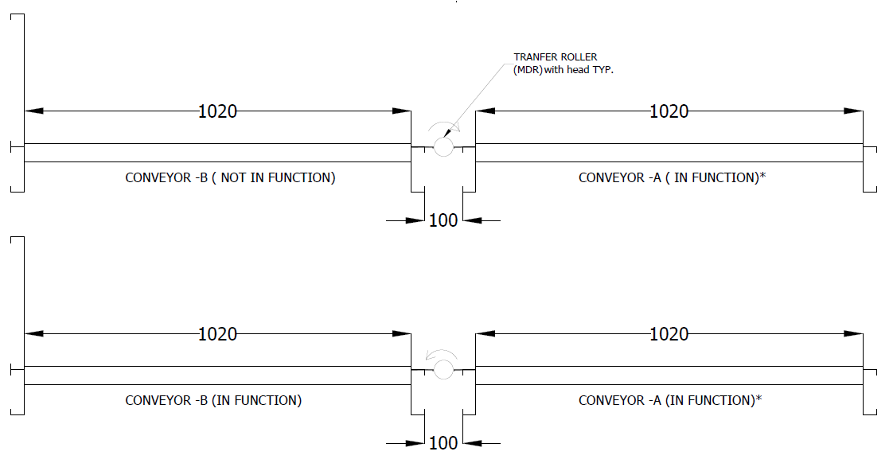
Figure 21. Direction of Transfer rollers when Conveyor B is enabled/disabled
It consists of the DIST-14-01 distribution board, as shown in the following table. The control power on the cards in this section was implemented from the RIO 1 distribution board.

The following Table shows the distribution boards, cards and motors activated for the operation of this section.

DB ID | Card ID | Roller ID's
DIST-14-01 | DIST-14-01.CAR.1 | DIST-14-01.CAR.1.ROL.A
 |  | DIST-14-01.CAR.1.ROL.B
 | DIST-14-01.CAR.2 | DIST-14-01.CAR.2.ROL.A
 |  | DIST-14-01.CAR.2.ROL.B
 | DIST-14-01.CAR.3 | DIST-14-01.CAR.3.ROL.A
 |  | DIST-14-01.CAR.3.ROL.B
 | DIST-14-01.CAR.4 | DIST-14-01.CAR.4.ROL.A
 |  | DIST-14-01.CAR.4.ROL.B
 | DIST-14-01.CAR.5 | DIST-14-01.CAR.5.ROL.A
 |  | DIST-14-01.CAR.5.ROL.B
 | DIST-14-01.CAR.6 | DIST-14-01.CAR.6.ROL.A
 |  | DIST-14-01.CAR.6.ROL.B
 | DIST-14-01.CAR.7 | DIST-14-01.CAR.7.ROL.A
 |  | DIST-14-01.CAR.7.ROL.B
 | DIST-14-01.CAR.8 | DIST-14-01.CAR.8.ROL.A
 |  | DIST-14-01.CAR.8.ROL.B

Control system.

The control system operates on a Siemens S7 1515F 2 PN PLC, which handles all the main logic, writing and reading information to and from the field devices. Using Profinet communication, it manages a series of peripherals where the digital input and output cards are installed. As mentioned earlier, through this communication protocol, the PLC exchanges information with the control cards that manage the roller motors and connected sensors. The system also includes a series of pushbuttons and light indicators managed by the input and output cards, as well as a Siemens MTP1200 series HMI screen for operation and monitoring. This manual explains the operating modes of the system for operational purposes.

Pushbuttons, Selectors and indicators.
The system has a series of pushbuttons, selectors, indicators and an HMI panel where the operator can monitor and control the system. This section will explain the general operation of the buttons and selectors found on the system.

Control from main control panel.

The main control panel houses all the primary electrical and electronic components of the system. Here, operators or users will find a series of buttons, indicators, circuit breakers, meters, and an HMI screen that displays the status of the system and its devices. The next section includes a figure describing the MCC panel and its control elements.

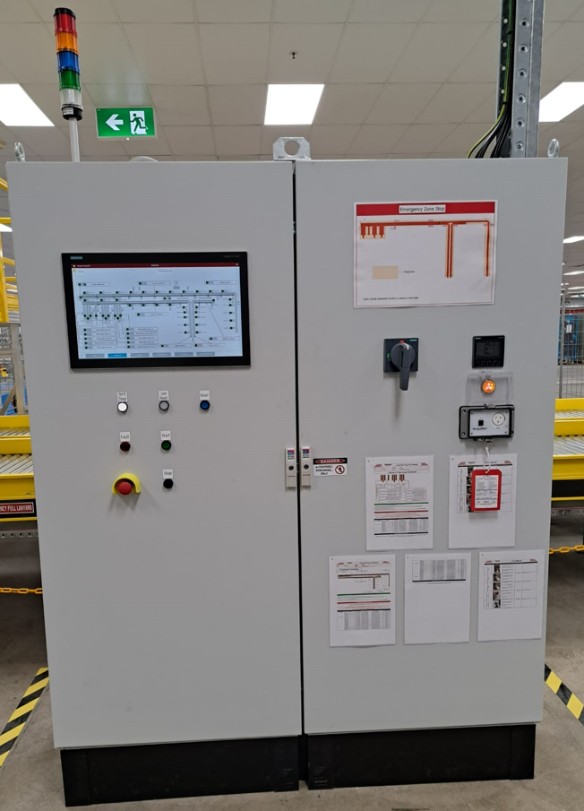
12
4
3
2
1
Figure 22. Main control panel MCC.
The main control panel is composed for:

- Main insulator. This has the function of powering the main panel and the field subsystems.

- Energy Meter: The Siemens PAC3220 meter can display and monitor various factors of the system's energy consumption. For more details, please refer to the device manual.

- Control Screen (HMI): This control screen is the primary interface for controlling and monitoring the system and its devices.
- Main Panel Control Buttons: This section allows the operator to quickly control and monitor the system without using the HMI. The following figure illustrates the buttons and indicators that the operator can use for control purposes.
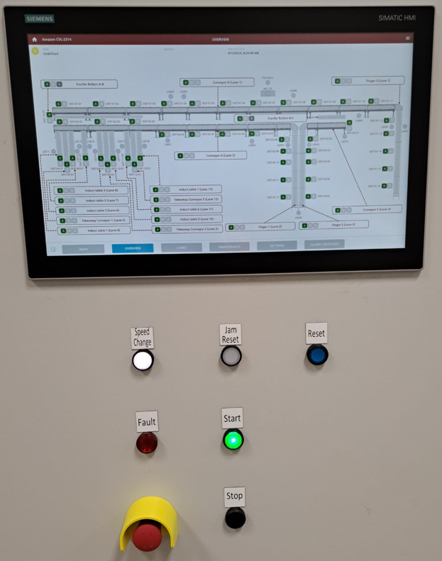
10
11
9
8
5
6
7
Figure 23. Main control panel MCC.

- Start push button and indicator. Start button has the functionality of operating the system automatically, when the system evaluates the status of the devices and if they are in a state of correct operation, the system begins to operate automatically. If some of the sections stop due to emergency stop, the other section is running, and the system is safe to restart, the user must acknowledge the alarms and press start on the HMI in this way the starting sequence for that section starts again. The button includes a light indicator that shows the system's status. The indicator behaves differently depending on the system's condition. The statuses of the indicator are as follows:

- Light off. System stopped.
- Light steady on. System Running.
- Light flashing 1Hz. Energy safe mode active.
- Light flashing 2Hz. System starting.

- Stop push button and indicator. Stop push button has the functionality of stopping the system when the operator presses it.

- Reset push button and indicator. When the user or operator presses the reset button, the event can be reset alarm or events at the PLC and HMI if the event is not still present. The button includes a light indicator that shows the system's status. The indicator behaves differently depending on the system's condition. The statuses of the indicator are as follows:

- Light flashing 1Hz. The system has a general alarm active and needs to be reset.
- Light flashing 2Hz. The system is in emergency status active and needs to be reset.

- Jam Reset push button and indicator. Jam detection is present in areas of the system at risk of container jams, such as merge points and curves. When one of the sensors located at the entrance to the Fingers curve detects a box for more than 10 seconds while the motors are running, it activates the Jam alarm and stops the lane. The operator must remove any obstructing elements in front of the sensor. This button is used to reset the alarms after clearing the jam. The button includes a light indicator that shows the system's status. The indicator behaves differently depending on the system's condition. The statuses of the indicator are as follows:

- Light off. Jam area healthy.
- Light steady on. Local jam condition has been detected within the jam reset station area of control and jam is still active.
- Light flashing 1Hz. Local jam condition has been removed and the system or the lane can be restarted.

- Speed change push button and indicator. This button functions to adjust the system's speed during normal operation, cycling through speeds 1 to 3 with each press. If pressed while the system is at speed 3, it switches back to speed 1. The button includes a light indicator that shows the system's status. The indicator behaves differently depending on the system's condition. The statuses of the indicator are as follows:

- Light steady on. The system is running at speed 1.
- Light flashing 1Hz. The system is running at speed 2.
- Light flashing 2Hz. The system is running at speed 3.

- Fault light indicator. The fault indicator displays when the system enters an emergency state, which occurs when an emergency stop is activated either from the buttons or the lanyards.

- MCC Emergency stop. This has the function of stopping the system and disabling the safety contactors.

- Main Panel Light Tower: This component serves the purpose of promptly informing operators about the system's status. The following figure illustrates the array of indicators included in the tower.

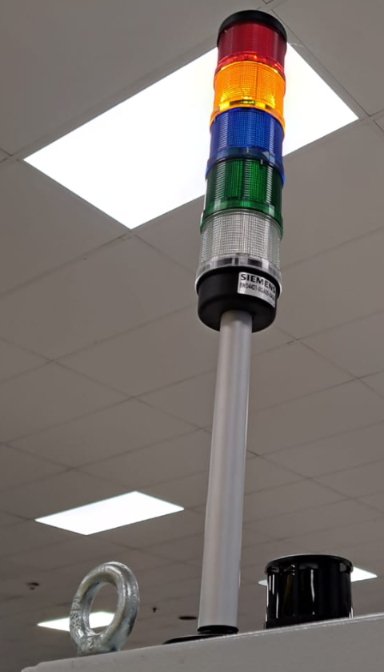
17
16
18
15
14
13
Figure 24. Main Panel Light Tower.

- Main Panel Red Light Tower. The red-light indicator displays when the system enters an emergency state, which occurs when an emergency stop is activated either from the buttons or the lanyards.

- Main Panel Amber Light Tower. The Amber light indicator displays when the system has a general fault. The indicator's behaviour varies depending on the system's condition. The statuses of the indicator are as follows:

- Light steady on. Maintenance mode active.
- Light flashing 1Hz. System in general alarm state.
- Light flashing 2Hz. System in Emergency state.

- Main Panel Blue Light Tower. The blue-light indicator displays when the system is in alarm and a reset is necessary to continue the operation. The indicator's behaviour varies depending on the system's condition. The statuses of the indicator are as follows:

- Light flashing 1Hz. The system has a general alarm active and needs to be reset.
- Light flashing 2Hz. The system is in emergency status active and needs to be reset.

- Main Panel Green Light Tower: The green-light indicator displays when the system is running, ready to run, in energy-saving mode, and during system startup. The indicator's behaviour varies depending on the system's condition. The statuses of the indicator are as follows:
- Light off. System stopped.
- Light steady on. System Running.
- Light flashing 1Hz. Energy safe mode active.
- Light flashing 2Hz. System starting.

- Main panel white light tower: the white light indicator is displayed when the system is in speed slowdown mode. This happens when operators press the button in the field and the section where it was pressed reduces the speed to 1. The indicator's behaviour varies depending on the system's condition. The statuses of the indicator are as follows:

- Light off. System at operator selected speed.
- Light flashing 1Hz. Slowdown mode.

- Main panel buzzer: The buzzer operates in two events: firstly, during system startup to alert operators and staff that the system is beginning operation (1Hz stops after 5 seconds). Secondly, during emergencies when activated, it signals to operators and staff that the system is in an emergency state and is stopped (constant for 5 seconds before the lane started).

Push buttons, selector, and indicator for Fingers.

Each Finger is equipped with set of start/stop buttons. When the start button is pressed, a warning alarm sounds, and the finger starts operating. In addition to the push buttons, these lanes have a selector switch that changes the traffic flow mode of the units. When the selector is set to Fwd (forward), the traffic flow of the units runs from the main conveyor towards the end of the fingers. If the selector is set to Rev (reverse), the units or the traffic flow changes direction from the end of the fingers to the main conveyors. Each time the flow direction of the fingers is changed, they stop and must be restarted. The lane has extra buttons that release the ZPA output of the last roller, allowing them to run and clear the line of units or boxes. The following figure shows the typical location of the local controls.

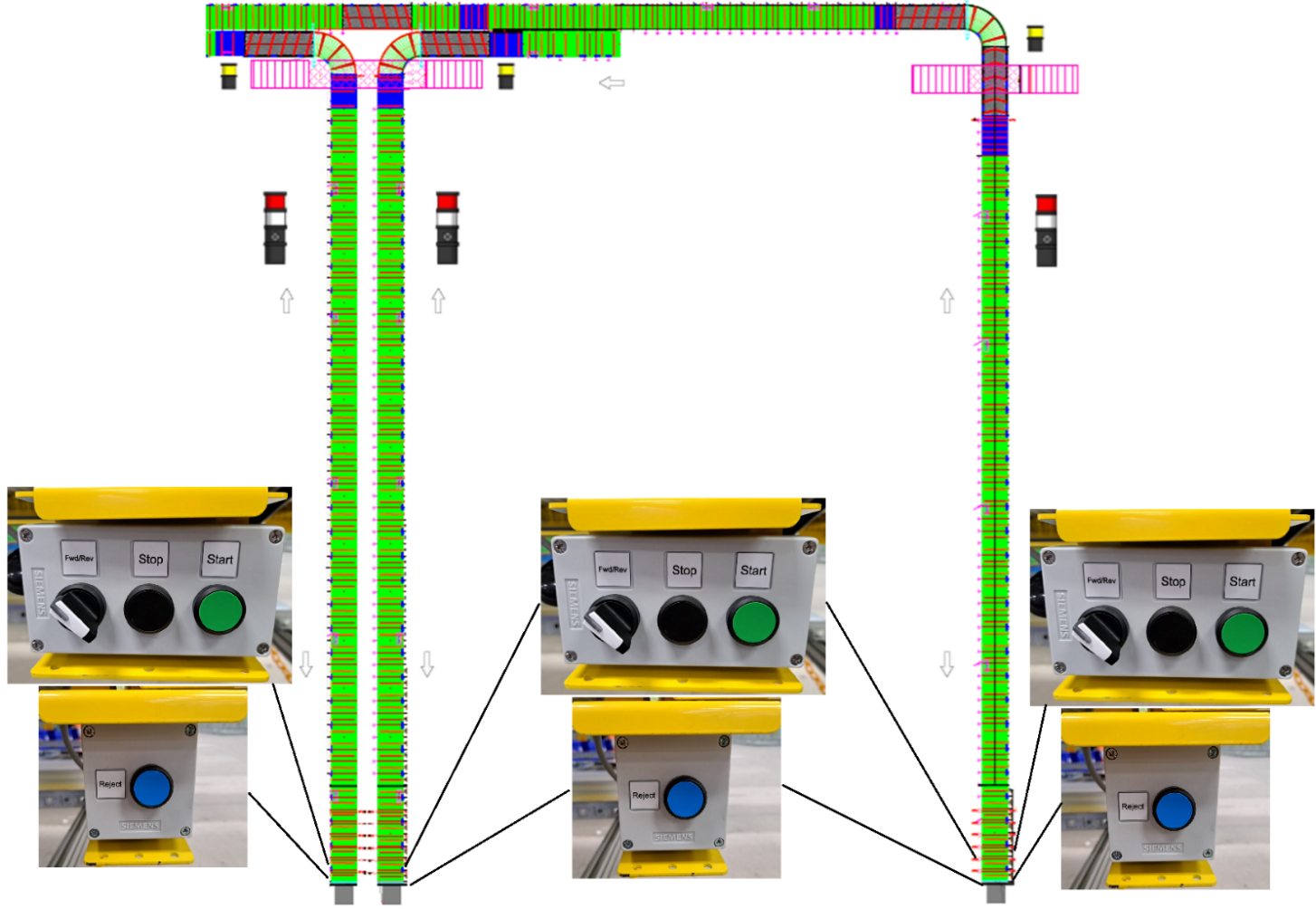
Figure 25. Local control Fingers.
Slowdown push button and indicator. When operators press the button in the field Slow down push button and the section where it was pressed reduces the speed to 1. If this is activated 3 times withing 5 minutes, the entire system will stop. If the slowdown button is pressed within 30 seconds of the initial slowdown commencement (slowdown time not yet elapsed), the slowdown will be cancelled, and the affected section will return to full speed. The indicator's of the button and the white indicators on the light tower behaviour varies depending on the system's condition. The statuses of the indicator are as follows:

- Light off. System at operator selected speed.
- Light flashing 1Hz. Slowdown mode.

The following figures show the location of the typical assembly of the slowdown control buttons and their light indicators.

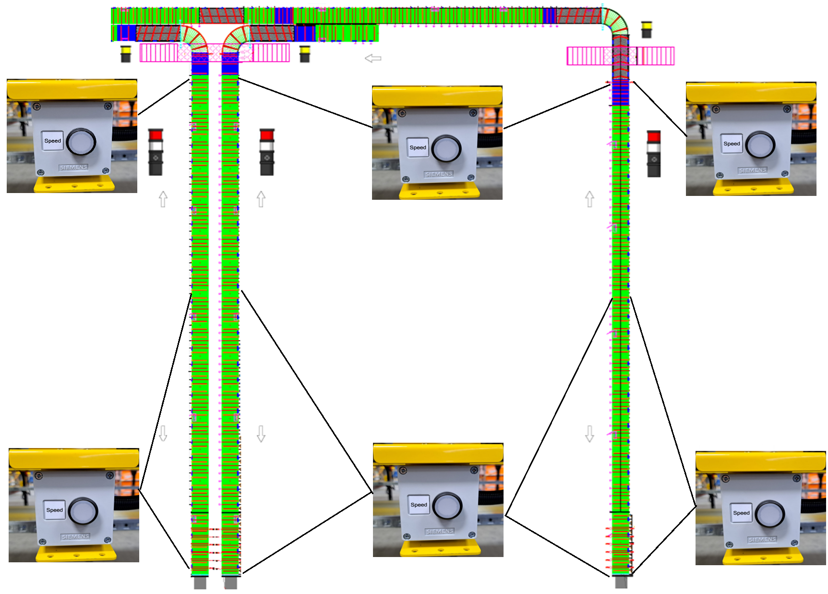

Figure 26. Local control slowdown push button Fingers.
The following figure shows the light indicators on the fingers. One of the light towers includes not only the white indicator but also the red indicator and the lane or finger buzzer. The buzzer operates in two events: firstly, during system startup to alert operators and staff that the system is beginning operation (1Hz stops after 5 seconds). Secondly, during emergencies when activated, it signals to operators and staff that the system is in an emergency state and is stopped (constant for 5 seconds before the lane started). The red-light indicator displays when the system enters an emergency state, which occurs when an emergency stop is activated either from the buttons or the lanyards. The indicator's behaviour varies depending on the system's condition. The statuses of the indicator are as follows:

- Light steady on. If the emergency stop device which triggered the emergency is in the zone where the lanyard is.
- Light flashing 1Hz. If the emergency stop device which triggered the emergency is not in the zone where the lanyard is.

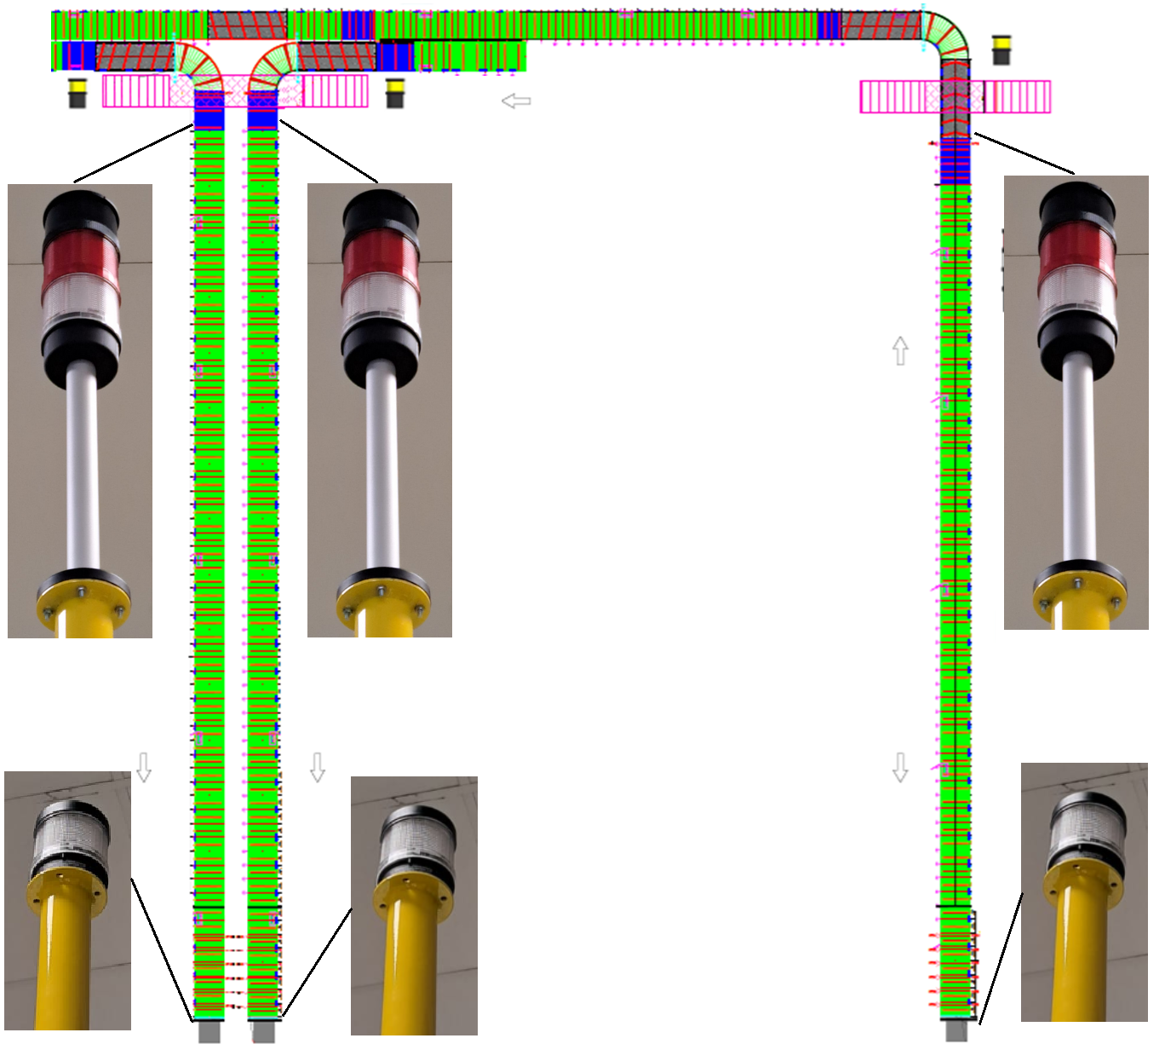
Figure 27. Local indicator Fingers.
Jam Reset push button and indicator. Jam detection is present in areas of the system at risk of container jams, such as merge points and curves. When one of the sensors located at the entrance to the Fingers curve detects a box for more than 10 seconds while the motors are running, it activates the Jam alarm and stops the lane. The operator must remove any obstructing elements in front of the sensor. This button is used to reset the alarms after clearing the jam. The button includes a light indicator that shows the system's status. The indicator behaves differently depending on the system's condition. The statuses of the indicator are as follows:

- Light off. Jam area healthy.
- Light steady on. Local jam condition has been detected within the jam reset station area of control and jam is still active.
- Light flashing 1Hz. Local jam condition has been removed and the system or the lane can be restarted.

Local Amber Light Tower. The Amber light indicator displays when the system has a jam in the curve section. The indicator's behavior varies depending on the system's condition. The statuses of the indicator are as follows:

- Light off. Jam alarm healthy.
- Light flashing 1Hz. Local Jam fault active
The following figure shows the location of the buttons to reset the Jam alarm and the amber light towers that inform operators and staff of this event.

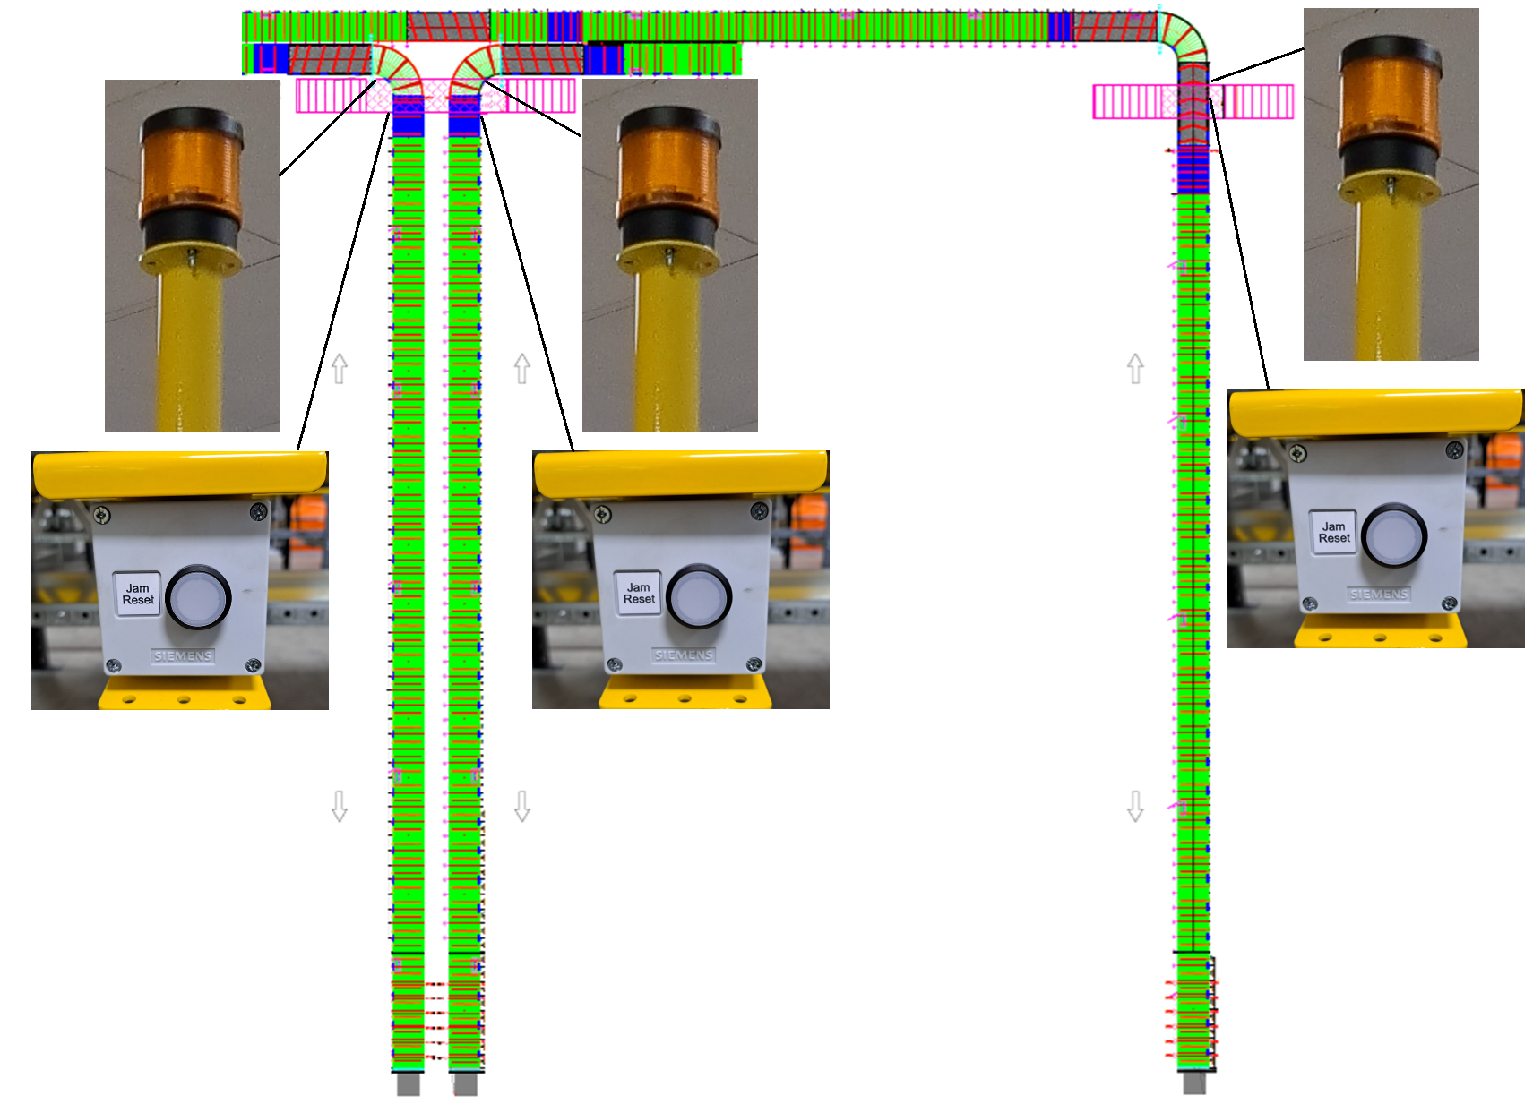
Figure 28. Local Jam reset control and indicator Fingers.

Push buttons and selector for Induct tables.

In Conveyor B, at the section where boxes or units are transferred from Conveyor B to Conveyor C, there is a slowdown button and a white light tower that indicates its operational status. When operators press the button in the field Slow down push button and the section where it was pressed reduces the speed to 1. If this is activated 3 times withing 5 minutes, the entire system will stop. If the slowdown button is pressed within 30 seconds of the initial slowdown commencement (slowdown time not yet elapsed), the slowdown will be cancelled, and the affected section will return to full speed. The indicator's of the button and the white indicators on the light tower behaviour varies depending on the system's condition. The statuses of the indicator are as follows:

- Light off. System at operator selected speed.
- Light flashing 1Hz. Slowdown mode.

The following figure shows the location of the button and the light indicator of the lane.

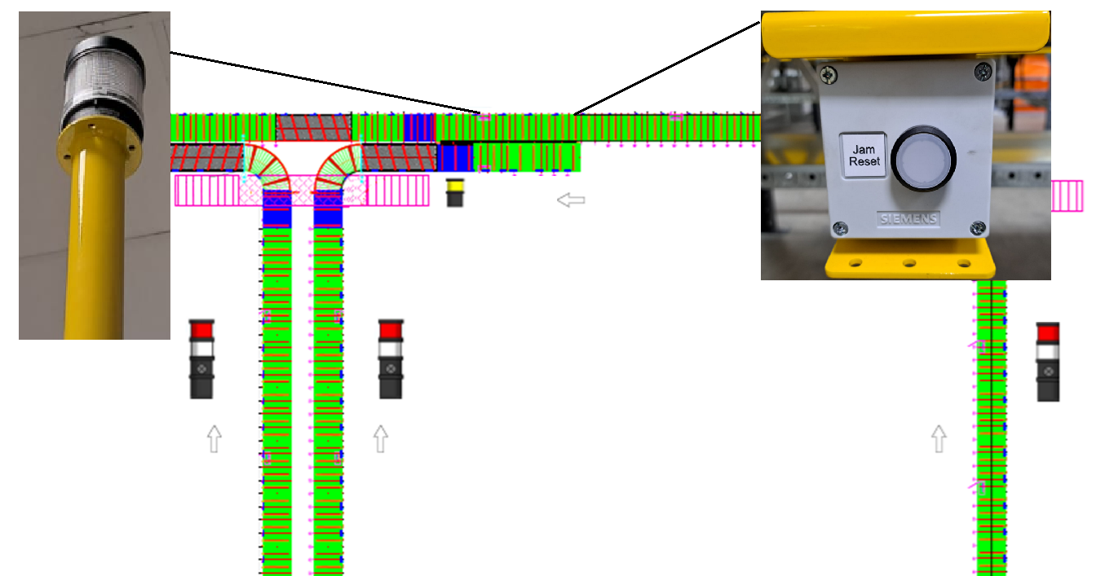

Figure 29. Local control slowdown push button and white indicator Conveyor B.

Push buttons and selector for Induct tables.

Each table is equipped with a start/stop button and a photoelectric sensor at the end. When the start button is pressed, a warning alarm sounds, and the induction table conveyor begins operating. In addition to the push buttons, these tables have a selector switch that changes the mode from automatic to manual (semi-automatic). When set to automatic, the system checks if conveyors A or B are running and allows the induction tables to start accordingly. If not, they stop to avoid collisions. In manual (semi-automatic) mode, the control is independent and does not consider the state of conveyors A or B. The following figure shows the typical location of the local controls, including the buttons and the selector switch.
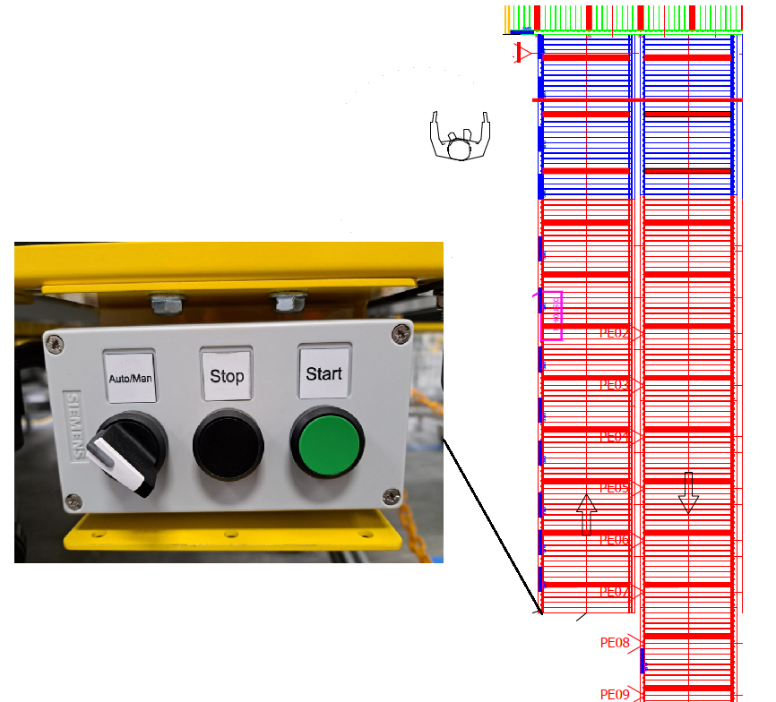

Figure 30. Local control Induct Tables.

Push buttons for Takeaway conveyor.

Each takeaway conveyor is equipped with two start/stop buttons. When the start button is pressed, a warning alarm sounds and the induction table conveyor starts operating. In addition to these buttons, the lane has two extra buttons that release the ZPA output of the last roller, allowing them to run and clear the line of units or boxes. The following figure shows the typical location of the local controls.

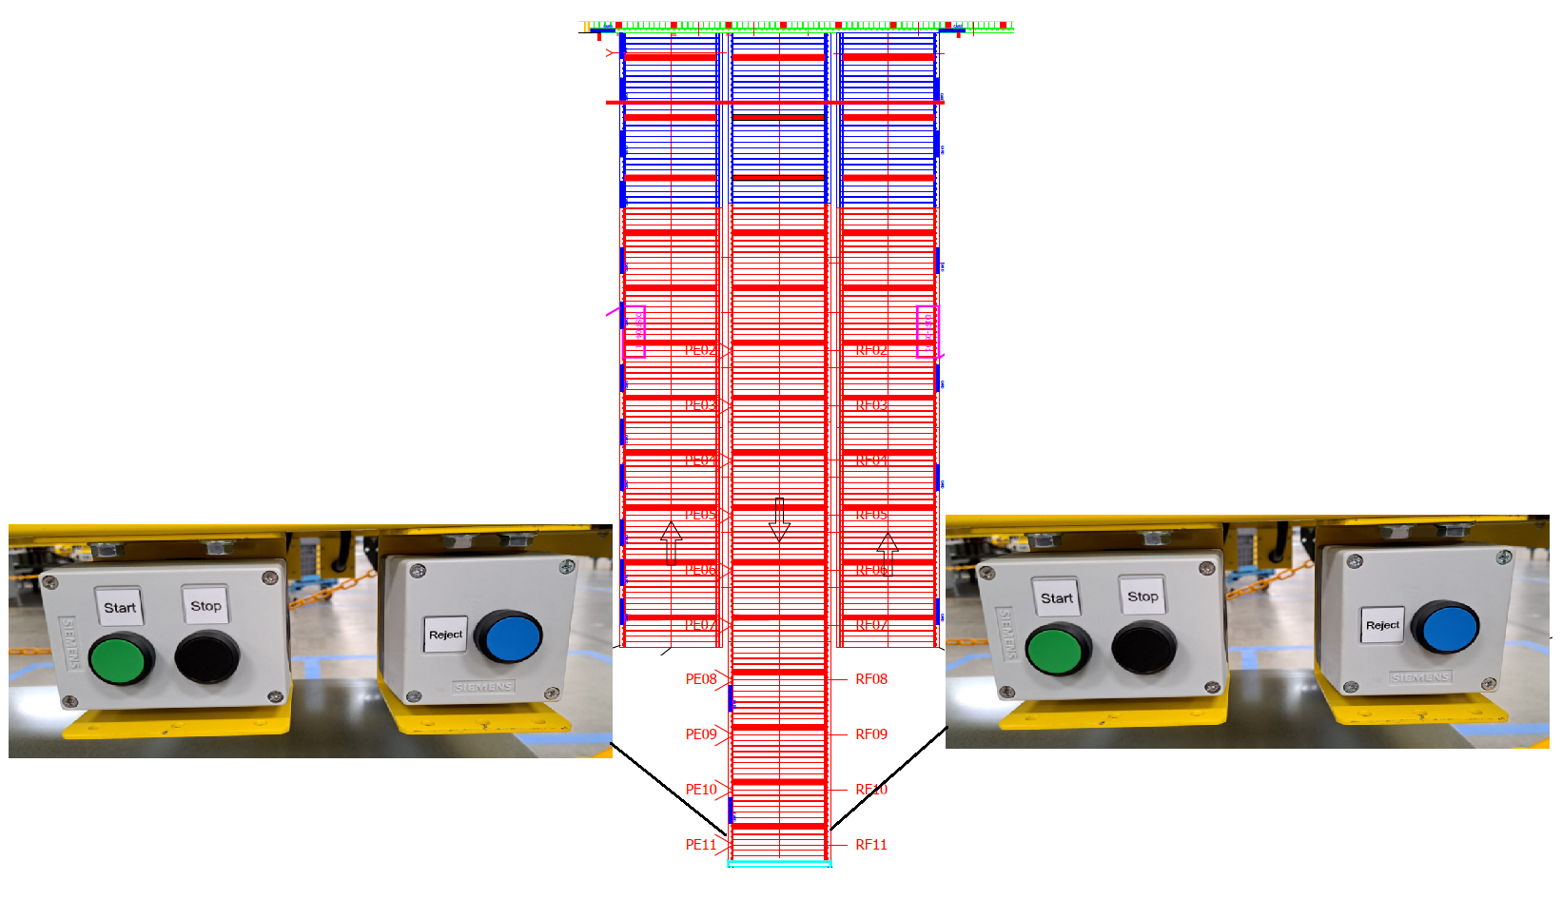
Figure 31. Local control Takeaway conveyor.

General Emergency stop and lanyards.
The system comprises 21 emergency stops that will immediately halt operation. Additionally, the system manages a signal from the fire system, which will stop the system until the signal is cleared from the fire panel and reset in the transportation system. The following figure shows the location of the emergency stop and lanyards.
21
6
4
5
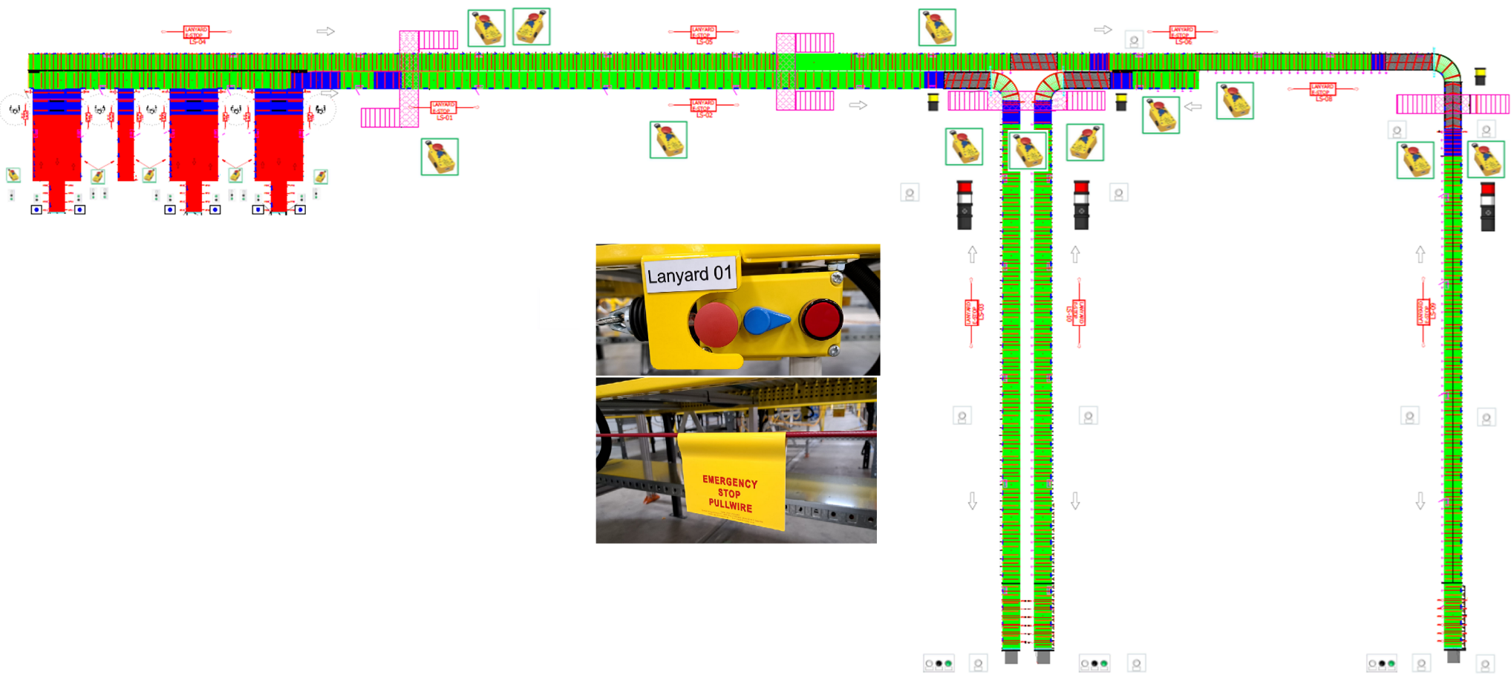
20
19
18
17
16
15
14
13
12
10
3
2
11
8
7
9
1
Figure 32. Top view, conveyor system1.

- Emergency Stop Lanyard 01.
- Emergency Stop Lanyard 02.
- Emergency Stop Lanyard 03.
- Emergency Stop Lanyard 04.
- Emergency Stop Lanyard 05.
- Emergency Stop Lanyard 06.
- Emergency Stop Lanyard 07.
- Emergency Stop Lanyard 08.
- Emergency Stop Lanyard 09.
- Emergency Stop Lanyard 10.
- Emergency Stop Lanyard 11.
- Emergency Stop Lanyard 12.
- Emergency Stop Lanyard 13.
- Emergency Stop Lanyard 14.
- Emergency Stop Lanyard 15.
- Emergency Stop Lanyard 16.
- Emergency Stop Lanyard 17.
- Emergency Stop Lanyard 18.
- Emergency Stop Lanyard 19.
- Emergency Stop Lanyard 20.
- Emergency Stop MCC.

HMI navigation.

The main control and monitoring point for the operator is the HMI screen, in this section the general navigation and the elements that compose it will be explained. The following figure shows the main screen, numbering the navigation elements.
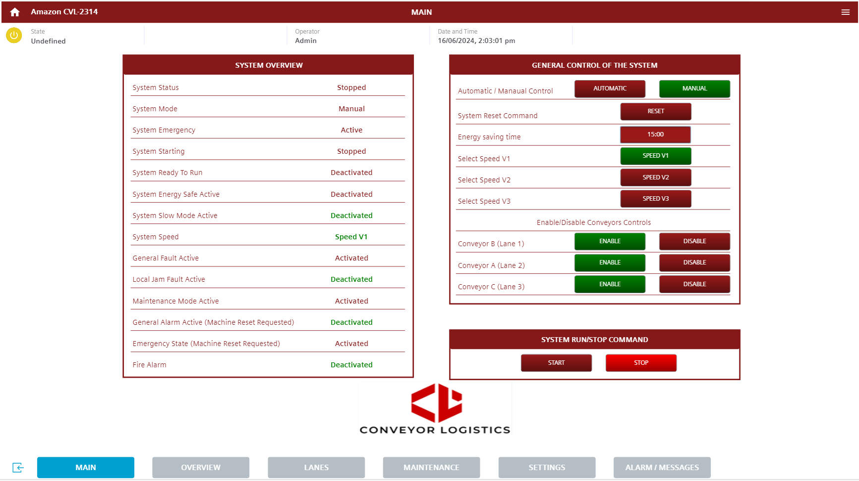
8
1
3
4
7
6
5
2
Figure 33. HMI navigation.

The HMI navigation elements is composed for:
- Screen title. At the top is the title of the current screen, this makes it easy to identify the screens.

- MAIN. At the bottom is the button to reload the MAIN screen or if the user is in another screen, they can return to the MAIN screen by pressing this button.

- OVERVIEW. Pressing this button loads the OVERVIEW screen, this screen shows the user the animation of all the main devices of the system.

- LANES. Pressing this button loads the LANES screen, this screen the user can monitor and control the lanes with their specific devices.

- MAINTENANCE. Pressing this button loads the MAINTENANCE screens, these screens show the user the information on the status and control of the equipment and devices that the system is composed.

- SETTINGS. Pressing this button loads the SETTINGS screen, this screen shows the user the main configuration of the system.

- ALARM / MESSAGES. Pressing this button loads the FAULTS screen, this screen shows the user all the faults, warnings and alarms that may be active and a history of them.

- MENU. Auxiliary window where the user can navigate the HMI.
3
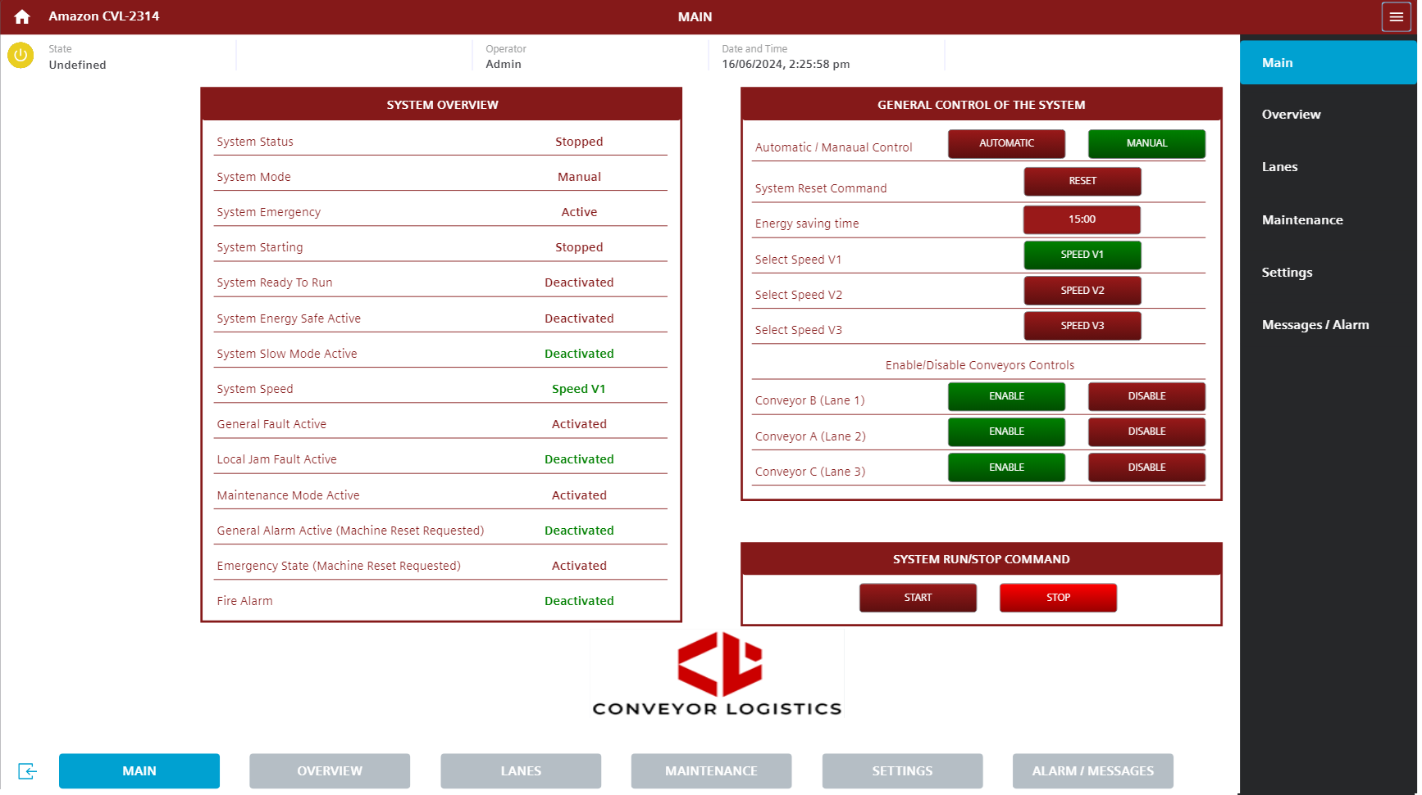
7
6
5
4
2
1
Figure 34. HMI navigation.

HMI Main Screen.

When the HMI application starts to run, the first screen that is loaded is MAIN screen, this screen shows the general states of the system and the control to activate the system in automatic mode. The screen is shown in the following figure.


21
20
19
18
17
16
15
14
13
12
11
10
9
8
7
6
5
4
3
2
1
Figure 35. HMI Main Screen.

The HMI Main Screen is composed for:
- System Status. At this point the user can see the status of the system which are:

- Stopped. It is displayed to inform the user that the system is completely stopped.
- Running. It is displayed to inform the user that the system is running in automatic or in manual.

- System Mode Status. At this point the user can see the Mode status of the system which are:

- Manual.
- Automatic.

- System Emergency. If there is a safety equipment outside the safety range or an emergency stop is pressed, the system at this point shows the user that is Fault “Active”, on the contrary if the system is ready to work it will show "Healthy".

- System Starting. This prompt shows the user when the system is Starting. The states are:

- Stopped
- Starting
- Running

- System Ready To Run. This indicator shows the user when the system is ready to run (Contactor and E-stop are healthy). The states are:

- Activated
- Deactivated

- System Energy Safe Active. This indicator shows the user when the system is in energy safe mode. When one of the zones or lanes is running and does not receive any signal from the sensors or controls for a time configured in the HMI, this area stops and goes into energy saving mode.

- System Slow Mode Active. When operators press the button in the field Slow down push button and the section where it was pressed reduces the speed to 1. If this is activated 3 times withing 5 minutes, the entire system will stop. If the slowdown button is pressed within 30 seconds of the initial slowdown commencement (slowdown time not yet elapsed), the slowdown will be cancelled, and the affected section will return to full speed. This indicator shows the user that the system is in this mode.

- System Speed. This indicator informs the speed selected by the operator or user.

- General Fault Active. This indicator reports general system failures such as sensor motor control card failures or communication errors.

- Local Jam Fault Active. Jam detection is present in areas of the system at risk of container jams, such as merge points and curves. When one of the sensors located at the entrance to the Fingers curve detects a box for more than 10 seconds while the motors are running, it activates the Jam alarm and stops the lane.

- Maintenance Mode Active. This indicator informs if any motor or section of the system is undergoing maintenance.

- General Alarm Active (Machine Reset Requested). At this point is where the user quickly monitors if the system has any faults active.

- Emergency State (Machine Reset Requested). At this point is where the user quickly monitors if the system has any emergency faults active.

- Fire Alarm. The system manages a signal from the fire system, which will stop the system until the signal is cleared from the fire panel and reset in the transportation system.

- Automatic / Manual Control. Automatic manual control, if the user wants to change the control of the system from manual to automatic at this point is where the user can execute it. (Note: If the user presses automatic, all lanes will switch to automatic mode except for the induct tables where the selector is set to manual.)

- System Reset Command. When the user presses the reset button, the event can be acknowledged and reset at the PLC and HMI if the event is not still present.

- Energy saving time. When one of the zones or lanes is running and does not receive any signal from the sensors or controls for a time configured in the HMI, this area stops and goes into energy saving mode.

- Speed change buttons. This button functions to adjust the system's speed during normal operation at the HMI. The speed at which the control cards were configured will be shown below.

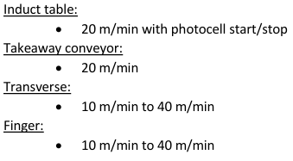
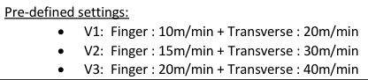

- Enable/Disable Conveyors Controls. In this field there are a series of buttons where the user can activate or deactivate the main lanes in automatic mode.

- START. Start button has the functionality of operating the system automatically, when the system evaluates the status of the devices and if they are in a state of correct operation, the system begins to operate automatically. If some of the sections stop due to emergency stop, the other section is running, and the system is safe to restart, the user must acknowledge the alarms and press start on the HMI in this way the starting sequence for that section starts again.

- STOP. Stop push button has the functionality of stopping the system when the operator presses it.

During operation ensure that the system is safe to operate. IT IS POSSIBLE TO DAMAGE THE EQUIPMENT AND INJURY PERSONNEL IN MANUAL OR AUTOMATIC MODE.
ONLY QUALIFIED PERSONNEL SHOULD OPERATE THIS MODE.
PAC TECHNOLOGIES REJECTS ANY REPONSIBILITY OF DAMAGE MADE TO EQUIPMENT AND PERSONNEL.

HMI Overview Screen.
Pressing the " OVERVIEW " button at the bottom of the screen loads the overview screen, this screen shows the user the animation of all the main devices, lanes and zones of the system, the screen is shown in the following figure.

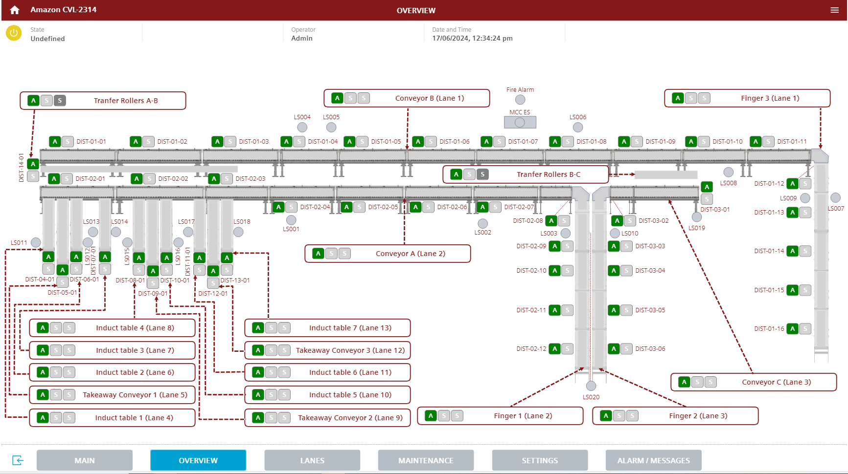
16
14
13
9
11
10
12
1
15
8
2
4
3

Figure 36. HMI Overview Screen.
The HMI Overview Screen is composed for:
- General Condition of the Lane: This indicator displays the lane name, control mode, status, and whether a motor or roller is running. When the operator selects or presses this indicator, a pop-up window opens, providing detailed lane status information. The following figure illustrates the pop-up window.
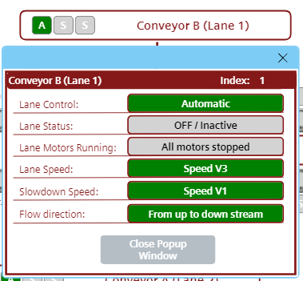
7
6
5
4
3
2
Figure 37. HMI pop-up window Lane general status.

- Lane control mode indicator. Lane Control Mode Indicator: This indicator changes colour and text to inform the user of the lane control mode. The following figures shows the possible states in which the lane can operate.

Indicator | Face plate indicator | Description
 |  | Lane in automatic mode. This mode control assigned from the MAIN screen (Note: If the user presses automatic at the Main screen, all lanes will switch to automatic mode except for the induct tables where the selector is set to manual).
 |  | Lane in Semi-Automatic or Local Manual Mode: In this mode, control is assigned from the specific lane screen on the 'Lane' control screen, where speed, flow direction, and other characteristics can be independently adjusted. The lane will continue to evaluate the other lanes, but the user can run or stop the lane without being affected by the status of other lanes. (Note: If the selector on the induction tables is set to Local Manual, this lane cannot be changed to automatic from the HMI).
 |  | Lane in Manual Mode Control Card: This mode is activated when the user selects manual on the Main Screen or when lane control is selected specifically for this lane. It allows each motor to run independently, but the control sequences and box transportation logic will not be followed. This mode is designed for maintenance purposes.
 |  | Lane in Maintenance Mode: This mode is selected when the lane is under maintenance. It allows the user to enable other lanes while keeping this lane off for maintenance without interfering with the operation of the other lanes.
Figure 38. Lane control mode indicator.

- Lane status indicator. This indicator changes colour to inform the user of the lane's status, depending on the logic, activity, and interaction of the devices and boxes being transported. The following figures show the possible states of the lanes.

Indi. | Face plate indicator | Description
Invalid, Unavailable, Bad Quality. Communication problem or none of the following states are valid
(Priority type = 2)
E- Stop activated. This status shows that one of the emergency stops has been activated
(Priority type = 2)
Motor fault. This status shows that one or several motors are in fault state.
(Priority type = 2)
Jam. This status shows that one of the sections has a jam alarm activated.
(Priority type = 4)
100% Full. If all the activated sensors in this lane are detecting units or boxes, it will show this status.
(Priority type = 5)
75% Full. If 75% of the activated sensors in this lane are detecting units or boxes, this status will be displayed.
(Priority type = 6)
50% Full. If 50% of the activated sensors in this lane are detecting units or boxes, this status will be displayed.
(Priority type = 6)
25% Full. If 25% of the activated sensors in this lane are detecting units or boxes, this status will be displayed.
(Priority type = 6)
Running or ON. If the zones that comprise the lane are running, the system will display this status.
(Priority type = 7)
Figure 39. Lane status indicator.

Indi. | Face plate indicator | Description
Energy management. Zones or lane is enabled or started but it's not running due to flow control (ie downstream is not ready).
(Priority type = 8)
Enabled, not running. Unit is enabled or started but it’s not running due to timeout for no activity.
(Priority type = 9)
OFF / Inactive. Zones or lane is not started or enabled.
(Priority type = 10)
Manual/Maintenance Mode. Zones or lane is in maintenance or in manual mode.
(Priority type = 4)
Internal emergency. The cabinet has an internal emergency active.
(Priority type = 1)
Figure 40. Lane status indicator.
If the lane is detecting multiple states, it will display the state with the lowest priority number in the priority type.

- Lane Rollers Status Indicator: This indicator primarily informs the user if any motors are running in the lane. The following figures illustrate the possible states of the lane rollers or motors.

indicator | Face plate indicator | Description
 |  | All motors stopped.
 |  | One or more motors running.
Figure 41. Lane Rollers Status Indicator.
- Lane Speed indicator. This indicator informs the user of the current speed at which the lane is operating, whether in automatic or semi-automatic mode. This speed may change depending on the lane specifications.

Face plate indicator | Description
 | Speed indicator V1.
 | Speed indicator V2.
 | Speed indicator V3.
Figure 42. Lane Speed indicator.

The speed at which the control cards were configured will be shown below.




- Slowdown Speed indicator. This indicator informs the user of the Slowdown Speed at which the lane is operating, whether in automatic or semi-automatic mode. This speed may change depending on the lane specifications.

Face plate indicator | Description
 | Slowdown Speed indicator V1.
 | Slowdown Speed indicator V2.
 | Slowdown Speed indicator V3.
Figure 43. Slowdown Speed indicator.

- Flow direction indicator. This indicator informs the user of the flow direction at which the lane is operating, whether in automatic or semi-automatic mode.

Face plate indicator | Description
 | Normal operation
 | Reverse flow
Figure 44. Flow direction indicator.

- Animation of the Zones: The following figure displays the typical animation of the areas o zones through which each lane is composed. Section 7 of the manual provides a summary of all the zones and the motors that constitute these zones.
10
11
9

12
Figure 45. Animation of the Zones.

- Name of the Zone. Zone Name: This text displays the name of the zone, which typically corresponds to the name of the distribution panel for easy identification. Section 7 provides a description of how each zone is composed with its devices.

- Zone Control mode Indicator: This indicator functions to inform the user or operator about the status of the zone. Detailed descriptions of the indicator can be found in Figure of the Lanes screen section 8.5.

- Zone Rollers Status Indicator: This indicator primarily informs the user if any motors are running in the zone. . Detailed descriptions of the indicator can be found in Figure of the Lanes screen section 8.5.

- Animation of the zone status. Zone Status Animation: This animation serves to inform the user about the status of the area, changing its colour according to its current state. Detailed descriptions of the animation can be found in Figure of the Lanes screen section 8.5.

- Emergency stop Indicator. The purpose of this indicator is to inform the operator of the location of the emergency stop that is activated. The following figure shows an example of the states

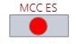
Figure 46. Animation of the E-Stop.

- Fire Alarm Indicator: The Fire Alarm Indicator displays a signal from the fire system, stopping the system until the signal is cleared from the fire panel and reset in the transportation system.

- Animation for the transfer roller: This animation serves to inform the user about the status of the area, changing its colour according to its current state. Detailed descriptions of the animation can be found in Figure of the Lanes screen section 8.5.

- Lane Selection HMI Lanes Screen. If the user or operator presses on the lane they wish to view, the HMI program will load the "Lane" screen, displaying the lane and its devices.

HMI Lanes Screen.

Pressing the LANES button at the bottom of the screen or selecting a lane on the OVERVIEW screen loads the lanes screen. Here, the user can view the general control of the lane, the status of the zones, and the devices within these areas., the screen is shown in the following figure.
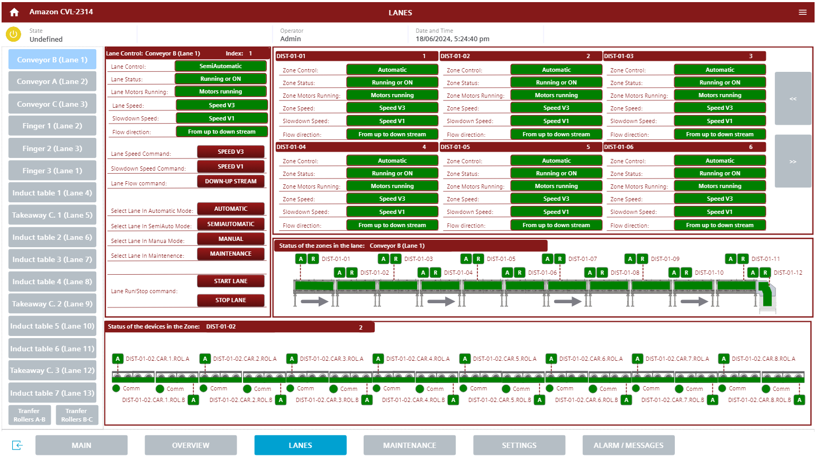
23
15
14
13
2
1
Figure 47. HMI Lanes Screen.
The HMI Devices Screen is composed for:
- Selection lane buttons. In this section the operator can select the lane he wants to monitor and control using the buttons.

- Lane Control: In this section, the user can see the status of the lane as described in Section XXX, Figure XXX. If the user has maintenance or administration access, they can control the lane, as shown in the following figure.

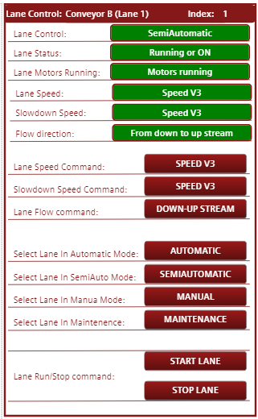
12
9
11
8
10
3
7
6
5
4

- Lane control title. In this field the user is informed which lane is loaded to monitor and control.

- Lane Speed Command. This button allows the operator or user to change the operating speed of the lane in semi-automatic mode. If the lane is in automatic mode, the variable will be overridden by the overall system speed.

- Slowdown Speed Command. This button allows the operator or user to change the slowdown speed of the lane in semi-automatic mode. If the lane is in automatic mode, the variable will be overridden by the global system speed.

- Lane Flow Command This button allows the operator or user to change the flow direction of the lane in semi-automatic mode. If the lane is in automatic mode, the variable will be overridden by the global system speed.

- Select lane in automatic mode. This button allows the operator or user to change the lane to automatic. This mode control assigned from the MAIN screen (Note: If the user presses automatic at the Main screen, all lanes will switch to automatic mode except for the induct tables where the selector is set to manual).

- Select lane in semiautomatic mode (Local Manual Mode). This button allows the operator or user to change the lane to Semi-Automatic or Local Manual Mode. In this mode, control is assigned from the specific lane screen on the 'Lane' control screen, where speed, flow direction, and other characteristics can be independently adjusted. The lane will continue to evaluate the other lanes, but the user can run or stop the lane without being affected by the status of other lanes. (Note: If the selector on the induction tables is set to Local Manual, this lane cannot be changed to automatic from the HMI).

- Select lane in manual mode: This button allows the operator or user to change the lane to manual. This mode is activated when the user selects manual on the Main Screen or when lane control is selected specifically for this lane. It allows each motor to run independently, but the control sequences and box transportation logic will not be followed. This mode is designed for maintenance purposes.

- Select lane in maintenance mode: This button allows the operator or user to change the lane to maintenance. This mode is selected when the lane is under maintenance. It allows the user to enable other lanes while keeping this lane off for maintenance without interfering with the operation of the other lanes.

- Lane Start. Start button has the functionality of operating the system in automatic and semiautomatic when the system evaluates the status of the devices and if they are in a state of correct operation, the system begins to operate automatically (Note: To run the lane from this section, it is necessary to start the system first from the MAIN screen.).

- Lane Stop. Stop push button has the functionality of stopping the lane when the operator presses it.

- General Condition of the Zones: This indicator displays the zones names, control mode, status, roller is running and another details of the zones. The following figure illustrates the zone status variables.


18
17
22
21
20
19
16
Figure 48. HMI Zone general status.

- Zone button navigation. Some lanes contain more than six zones; therefore, this section includes navigation buttons to display the zone indicators.

- Status of the zones in the lane. In this section, the operator or user can view the animations and states of each area of the lane. Pressing on an animation loads a panel at the bottom, where the user can see the rollers and sensors involved in that zone. In section 7 of the manual all the lanes of the system are presented.


16
19
18
17

- Zone control mode indicator. This indicator changes colour and text to inform the user of the lane control mode. The following figures shows the possible states in which the lane can operate.

Indicator | Face plate indicator | Description
 |  | Zone in automatic mode. This mode control assigned from the lane control.
 |  | Zone in Local Manual Mode: In this mode, control is assigned from the specific zone screen on the 'Lane' control screen, where speed, flow direction, and other characteristics can be independently adjusted. The lane will continue to evaluate the other zones, but the user can run or stop the lane without being affected by the status of other lanes.
 |  | Zone in Manual Mode Control Card: This mode is activated when the user selects manual on the Main Screen or when lane control is selected specifically for this zone. It allows each motor to run independently, but the control sequences and box transportation logic will not be followed. This mode is designed for maintenance purposes.
 |  | Zone in Maintenance Mode: This mode is selected when the zone is under maintenance. It allows the user to enable other zones while keeping this lane off for maintenance without interfering with the operation of the other lanes.
Figure 49. Zone control mode indicator.

- Name of the Zone. Zone Name: This text displays the name of the zone, which typically corresponds to the name of the distribution panel for easy identification. Section 7 provides a description of how each zone is composed with its devices.

- Zone status indicator. This indicator changes colour to inform the user of the lane's status, depending on the logic, activity, and interaction of the devices and boxes being transported. The following figures show the possible states and animation of the zones.

Animation | Face plate indicator | Description
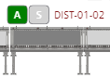 |  | Invalid, Unavailable, Bad Quality. Communication problem or none of the following states are valid  (Priority type = 2)
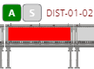 |  | E- Stop activated. This status shows that one of the emergency stops has been activated  (Priority type = 2)
 |  | Motor fault. This status shows that one or several motors are in fault state.  (Priority type = 2)
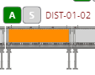 |  | Jam. This status shows that one of the sections has a jam alarm activated.  (Priority type = 4)
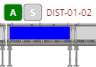 |  | 100% Full. If all the activated sensors in this lane are detecting units or boxes, it will show this status.  (Priority type = 5)
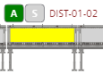 |  | 75% Full. If 75% of the activated sensors in this lane are detecting units or boxes, this status will be displayed.  (Priority type = 6)
 |  | 50% Full. If 50% of the activated sensors in this lane are detecting units or boxes, this status will be displayed.  (Priority type = 6)
Figure 50. Zone status indicator.

Animation | Face plate indicator | Description
 |  | 25% Full. If 25% of the activated sensors in this lane are detecting units or boxes, this status will be displayed.  (Priority type = 6)
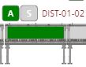 |  | Running or ON. If the zones that comprise the lane are running, the system will display this status.  (Priority type = 7)
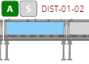 |  | Energy management. Zones or lane is enabled or started but it's not running due to flow control (ie downstream is not ready).  (Priority type = 8)
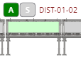 |  | Enabled, not running. Unit is enabled or started but it’s not running due to timeout for no activity.  (Priority type = 9)
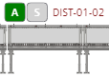 |  | OFF / Inactive. Zones or lane is not started or enabled.  (Priority type = 10)
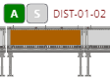 |  | Manual/Maintenance Mode. Zones or lane is in maintenance or in manual mode.  (Priority type = 4)
 |  | Internal emergency. The cabinet has an internal emergency active.  (Priority type = 1)
Figure 51. Zone status indicator.
If the lane is detecting multiple states, it will display the state with the lowest priority number in the priority type.

- Zone Rollers Status Indicator: This indicator primarily informs the user if any motors are running in the zone. The following figures illustrate the possible states of the lane rollers or motors.

indicator | Face plate indicator | Description
 |  | All motors stopped.
 |  | One or more motors running.
Figure 52. Zone Rollers Status Indicator.
- Zone Speed indicator. This indicator informs the user of the current speed at which the lane is operating, whether in automatic or semi-automatic mode. This speed may change depending on the lane specifications.

Face plate indicator | Description
 | Speed indicator V1.
 | Speed indicator V2.
 | Speed indicator V3.
Figure 53.Zone Speed indicator.
- Slowdown Speed indicator. This indicator informs the user of the Slowdown Speed at which the lane is operating, whether in automatic or semi-automatic mode. This speed may change depending on the lane specifications.

Face plate indicator | Description
 | Slowdown Speed indicator V1.
 | Slowdown Speed indicator V2.
 | Slowdown Speed indicator V3.
Figure 54. Zone Slowdown Speed indicator.

- Flow direction indicator. This indicator informs the user of the flow direction at which the lane is operating, whether in automatic or semi-automatic mode.

Face plate indicator | Description
 | Normal operation
 | Reverse flow
Figure 55. Zone Flow direction indicator.

The speed at which the control cards were configured will be shown below.




- Status of the devices in the zone. In this panel, the user or operator can see the devices, such as motors and sensors, involved in this area. The following figure shows an example of an area with 16 rollers on 8 cards.
24

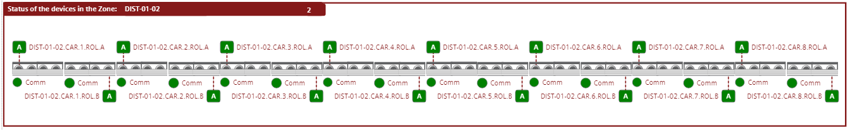
Figure 56. Status of the devices in the zone
- Animation of the Devices in the Zones: The motors and sensors have their own animations in Sections 8.5.1 and 8.5.2. The user can view a summary of the states of the motors and sensors, along with their indicators and a description of their behaviour. At the point where these devices are displayed, if the user presses or selects a device, a pop-up window opens, allowing the device to be controlled and monitored. Section 8.5.3 and Section 8.5.4 describes the operation of these pop-up windows. The following figure shows an example of the animation of the motors and sensors.


Figure 57. Status of the devices in the zone

Motors animations.

To facilitate the monitoring of the motors, an animation was developed by changing the colour of the element. The system provides the status of the equipment, informing the user quickly. The following figures show the different states of the motors and a description of each state.

Animation of the rollers. | Animation description
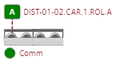 | Animation of the device when the motor is in automatic and is off.
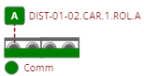 | Animation of the device when the motor is in automatic and is on.
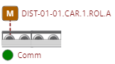 | Animation of the device when the motor is in manual and is off.
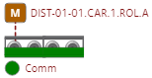 | Animation of the device when the motor is in manual and is on.
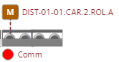 | Animation of the device when the motor has communication error.
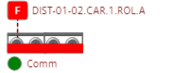 | Device animation when it is in fault.
Figure 58. Motor animations.

Animation of the rollers. | Animation description
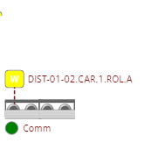 | Device animation when it is in warning and off.
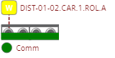 | Device animation when it is in warning and on.
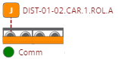 | Animation of the device when the motor has a jam.
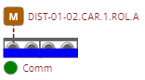  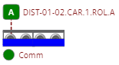 | Animation of the device when the motor is between the transition from start to stop and from stop to start.
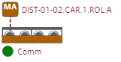 | Animation of the device when the motor is in maintenance status
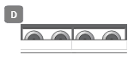 | Animation of the device when the motor is in disable
Figure 59. Motor animations.

Sensor animations, HMI overview screen.

To facilitate the monitoring of the digital sensors, an animation was developed by changing the colour of the element. The system provides the status of the equipment, informing the user quickly. The following figures show the different states of the sensors and a description of each state.

Sensors Animation | Animation description
 | Sensor animation when it does not detect units, or it is in the logic input turned off.
 | Sensor animation when it detects units or is in the logic input turned on.
 | Sensor animation when forcing or simulating not detecting units or forcing logic input off ignoring sensor input.
 | Sensor animation when forced or simulated to detect units or forcing logic input on ignoring sensor input.
 | Sensor animation when it does not detect units, or it is in the logic input turned off and it is in alarm
 | Sensor animation when it detects units or is in the logic input turned on and it is in alarm
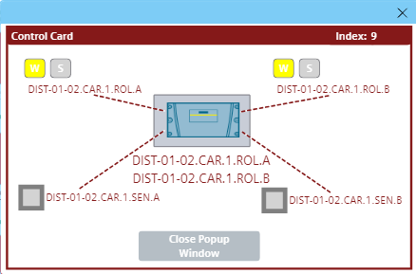 | Sensor animation when in disabled mode.

Figure 60. Sensor animations.

HMI Motors Popup Screen.

When the user is on the screens where the animations of the motors are located and selects or presses the animation, a pop-up screen opens where the user can monitor and control the motor. The control cards are electrically connected to the inputs and outputs of the PLC or through a communication protocol connected to the card, the following figure shows the pop-up screen.
3
2
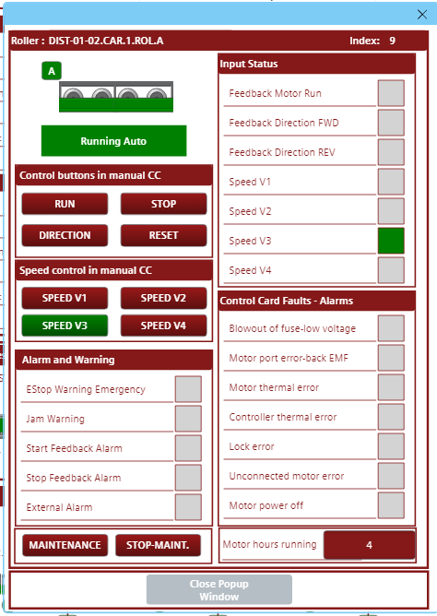
21
20
12
4
19
14
13
10
9
11
8
7
16
15
17
18
1
5
6
22
Figure 61. HMI motor Popup Screen.
The HMI Motors Popup Screen is composed for:
- Title of the pop-up screen. At this point, the user finds the name of the Motor to monitor and control.

- Motor number. This is the motor number according to the logic of the PLC program.

- Close icon. When the user presses this icon, the pop-up screen closes.

- Close button. When the user presses this button, the pop-up screen closes.

- Animation of the control state. This animation is not only found in the pop-up screen but also in the general monitoring screens, it has the function of informing the user of the control status of the motor.

- Motor animation. This animation informs the user of the status of the motor by changing the colour

- Manual control buttons. These buttons have the function of controlling the motor manually these buttons will be implemented for maintenance purposes.

- Reset. This button has the function of reset once the motor issue is corrected.

- Motor Forward operation. This indicator shows the user that the motor is running forward.

- Motor Reverse operation. This indicator shows the user that the motor is running reverse.

- Motor Run operation. This indicator shows the user that the motor is running.

- Speed control in manual. These buttons have the function of manually controlling the engine speed of the engine these buttons will be implemented for maintenance purposes.

- Speed feedback. These indicators have the function of informing the user of the currently selected speed for the engine.

- Motor Fault. These indicators show the user that the motor has faulted or not at the control card feedback.

- Emergency stops healthy. This indicator shows the user that the motor is not in an active emergency stop.

- Jam Warning. If the sensor detects units and the motor is running, a warning indicator shows to the user at this conveyor is a traffic jam.

- Run Feed-back Fault. This indicator shows the user that the motor has no feedback fault when it is running.

- Stop Feed-back Fault. This indicator shows the user that the motor has no feedback fault when the user stops the motor.

- External Alarm. This indicator shows the user that the motor has not faulted at the external logic alarm.

- Motor hours running. These indicators inform the user of the hours the engine has operated based on the feedback signal.

- Maintenance Buttons: These buttons allow the user to assign or stop a motor in maintenance mode, preventing conflicts with other motors operating in automatic mode.

- Status. This indicator shows the user a graphical status of the motor control. the following figures show the different states and their colours.

Status Animation | Animation description
 | Animation of the device when the motor is in automatic and is off.
 | Animation of the device when the motor is in automatic and is on.
 | Animation of the device when the motor is in manual and is off.
 | Animation of the device when the motor is in manual and is on.
   | Device animation when it is in fault.
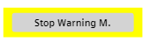   | Device animation when it is in warning and off.
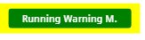  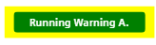 | Device animation when it is in warning and on.
 | Device animation when it is in Jam status
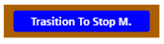   | Animation of the device when the motor is between the transition from start to stop
   | Animation of the device when the motor is between the transition from stop to start

Figure 62. Popup Screen, motors animations status

Status Animation | Animation description
 | Device animation when it is in maintenance mode
 | Animation of the device when the motor is in disable
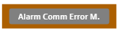 | Animation of the device when the motor has communication error.

Figure 63. Popup Screen, motors animations status

During operation ensure that the system is safe to operate. IT IS POSSIBLE TO DAMAGE THE EQUIPMENT AND INJURY PERSONNEL IN MANUAL OR AUTOMATIC MODE.
ONLY QUALIFIED PERSONNEL SHOULD OPERATE THIS MODE.
PAC TECHNOLOGIES REJECTS ANY REPONSIBILITY OF DAMAGE MADE TO EQUIPMENT AND PERSONNEL.

HMI Sensors Popup Screen.

When the user is on the screens where the animations of the sensors are located and selects or presses the animation, a pop-up screen opens where the user can monitor the sensor, the following figure shows the pop-up screen.
2
13
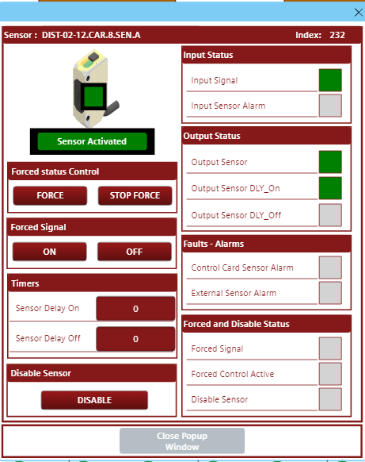
19
17
18
16
15
14
12
11
10
9
8
7
6
5
4
3
1
Figure 64. HMI sensor Popup Screen.

The HMI Sensors Popup Screen is composed for:
- Title of the pop-up screen. At this point, the user finds the name of the Sensor to monitor.

- Sensor number. This is the sensor number according to the logic of the PLC program.

- Close icon. When the user presses this icon, the pop-up screen closes.

- Digital Sensor Animation. Animation of the sensor informs the operator and the system that the sensor is activated or deactivated (Animation description in section 8.5.2 of the manual).

- Sensor status. This sensor indicator shows the user that the input status of the sensor logic is on or off.

- On/Off Delay. This sensor indicator shows the user that the sensor is on or off. This variable can have a delay when it is activated or a delay when it is deactivated.

- On Delay. This sensor indicator shows the user that the sensor is on with delay.

- Off Delay This sensor indicator shows the user that the sensor is off with delay.

- Forced. This sensor indicator shows the user that the sensor signal is forced or simulated.

- Forced Signal. This sensor indicator shows the user the status of the sensor signal when it forced or simulated.

- Force button. This button has the function of activating the forcing or simulation mode of the digital sensor.

- Signal button. This button has the function of activating or deactivating the signal of the sensor, forcing mode or simulation of the digital sensor.

- Input sensor alarm status. This sensor indicator shows the user that the input of the alarm coming from the control card status of the sensor logic.

- PLC sensor alarm status. This sensor indicator shows the user that the input of the alarm coming from the control card status of the sensor logic.

- External Alarm. This indicator shows the user that the sensor has not faulted at the external logic alarm.
- Timers. External Alarm. This indicator shows the user that the motor has not faulted at the external logic alarm.

- Disable button. This button has the function of disable the sensor from the logic.

- Disable sensor. This indicator shows the user that the sensor is disable.

- Status. This indicator shows the user a graphical status of the sensor control. the following figures show the different states and their colours.

Sensors Animation | Animation description
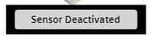 | Sensor animation when it does not detect units, or it is in the logic input turned off.
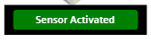 | Sensor animation when it detects units or is in the logic input turned on.
 | Sensor animation when forcing or simulating not detecting units or forcing logic input off ignoring sensor input.
 | Sensor animation when forced or simulated to detect units or forcing logic input on ignoring sensor input.
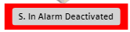 | Sensor animation when it does not detect units, or it is in the logic input turned off and it is in alarm
 | Sensor animation when it detects units or is in the logic input turned on and it is in alarm
 | Sensor animation when in disabled mode.

Figure 65. Popup Screen, sensor animations status

During operation ensure that the system is safe to operate. IT IS POSSIBLE TO DAMAGE THE EQUIPMENT AND INJURY PERSONNEL IN MANUAL OR AUTOMATIC MODE.
ONLY QUALIFIED PERSONNEL SHOULD OPERATE THIS MODE.
PAC TECHNOLOGIES REJECTS ANY REPONSIBILITY OF DAMAGE MADE TO EQUIPMENT AND PERSONNEL.

HMI Maintenance Screen.

Pressing the "MAINTENANCE" button at the bottom of the screen loads the maintenance screen, which displays the PLC communication network and its connected devices. For the control cards, it will primarily show the master card or card number 1 of each distribution panel. The screen and navigation buttons are shown in the following figure.
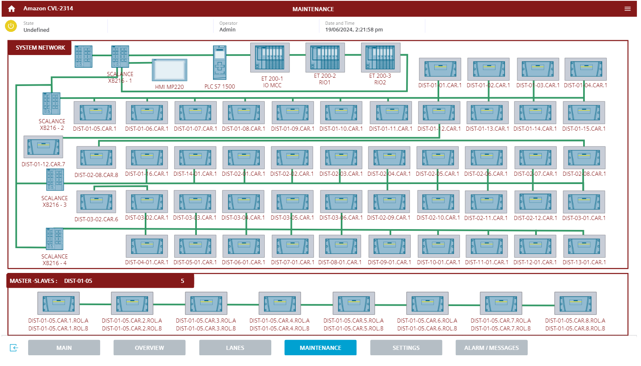
8
7
6
5
4
1
3
2
Figure 66. HMI Maintenance.

The HMI Maintenance composed for:

- HMI. The HMI screen has no animation; it is for informational purposes only.

- PLC. The PLC has no animation; it is for informational purposes only.

- ET200 IO MCC Periphery Animation: This device manages the input and output cards with the PLC. If the PLC loses communication with this device, the animation will change to red to inform the user that the connection has been lost.

- ET200 RIO1 Periphery Animation: This device manages the input and output cards with the PLC. If the PLC loses communication with this device, the animation will change to red to inform the user that the connection has been lost.

- ET200 RIO2 Periphery Animation: This device manages the input and output cards with the PLC. If the PLC loses communication with this device, the animation will change to red to inform the user that the connection has been lost.

- Control Card Animation: This animation indicates if there is a communication failure between the master card and the PLC, or between the master card and its slave cards. The following figure shows an example of when communication is lost with some cards.
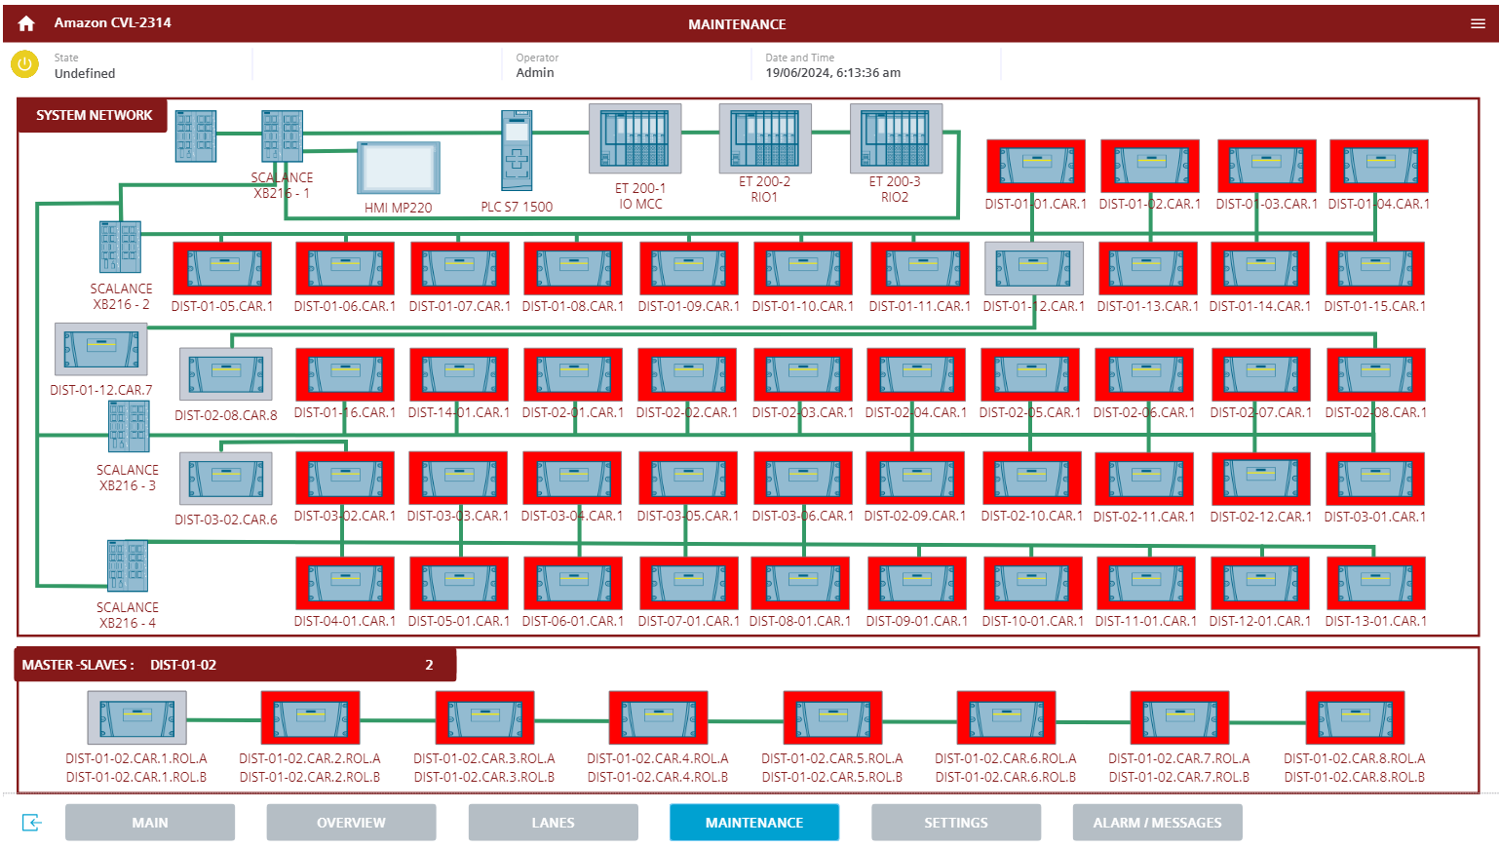
Figure 67. HMI Maintenance.

- Master-Slaves panel. When the operator selects or presses on any of the master cards, this section displays the communication status of the master card with its slaves (Note not all distribution panels contain 8 cards).

- Cards: In the box where the master card and its slaves are displayed, selecting or pressing on it opens a pop-up window where the user can see the elements connected to this card and their operational status (At this point is where the user opens the pop-up window of the sensors and motors that are disabled). An example of this pop-up window is shown in the following figure.

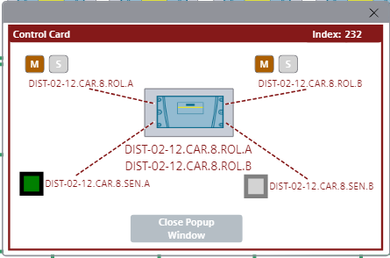
Figure 68. HMI Maintenance Control Card devices.

During operation ensure that the system is safe to operate. IT IS POSSIBLE TO DAMAGE THE EQUIPMENT AND INJURY PERSONNEL IN MANUAL OR AUTOMATIC MODE.
ONLY QUALIFIED PERSONNEL SHOULD OPERATE THIS MODE.
PAC TECHNOLOGIES REJECTS ANY REPONSIBILITY OF DAMAGE MADE TO EQUIPMENT AND PERSONNEL.

HMI Settings Screen.

Pressing the " SETTINGS " button at the bottom of the screen loads the settings screen, this screen shows the user some important state variables and the user control for the HMI, the screen is shown in the following figure.

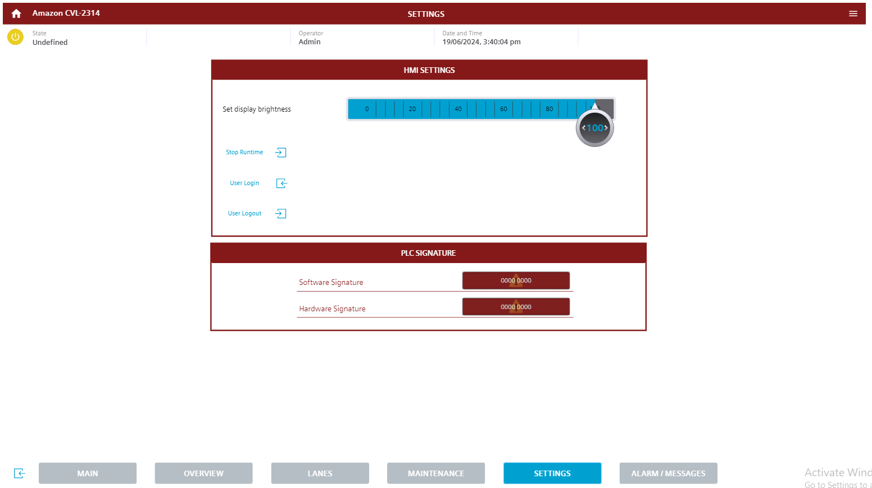
6
1
7
5
4
3
2
Figure 69. HMI Settings Screen.

The HMI Settings Screen is composed for:
- PLC Signature. At this point the user can see the software and hardware signature that the PLC has and its security cards.

- HMI Settings. In this section the user can access the settings of the Wincc Unified comfort screen.

- Set to display brightness.

- Stop Runtime. This button allows the user to stop the application or runtime. Before stopping, the system will prompt the user to confirm this action. The following figure shows the confirmation message.

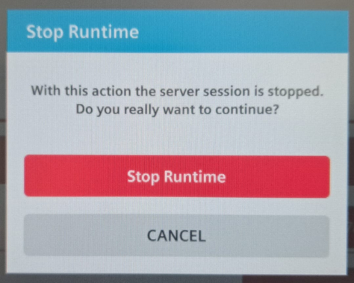
Figure 70. Stop Runtime popup screen.

- User login button. Pressing this button opens a popup screen where the user can enter their username and access password, when the user logs in he can have access to some control variables mentioned above. The following figure shows the popup screen.

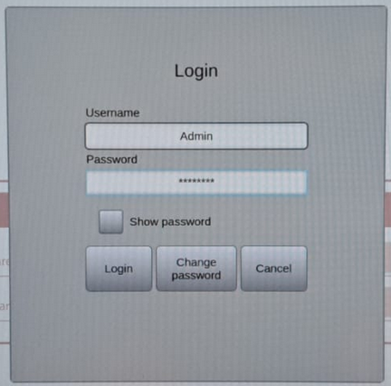
Figure 71. Login popup screen.

- User or operator. Once the user is active, their name can be seen at the top of the screen.

- User logout button. Pressing this button, the user can log out from the user access.

If the operator wants to enter the user administrator, it is necessary to stop the runtime as described above, when the screen configuration is displayed as shown below.

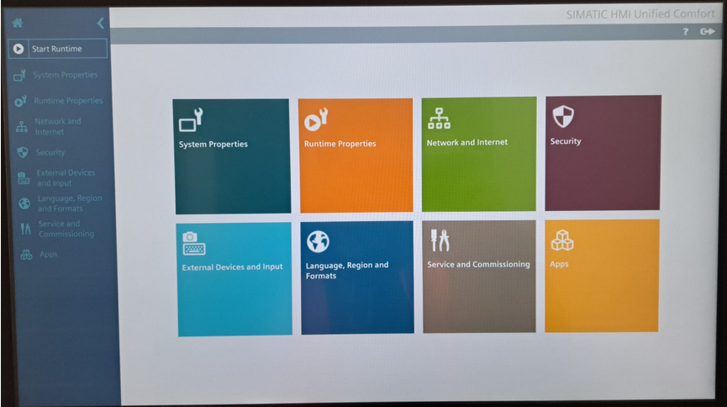
Figure 72. OS Comfort panel.

Once stopped, the user has to enter the security screen and user management.

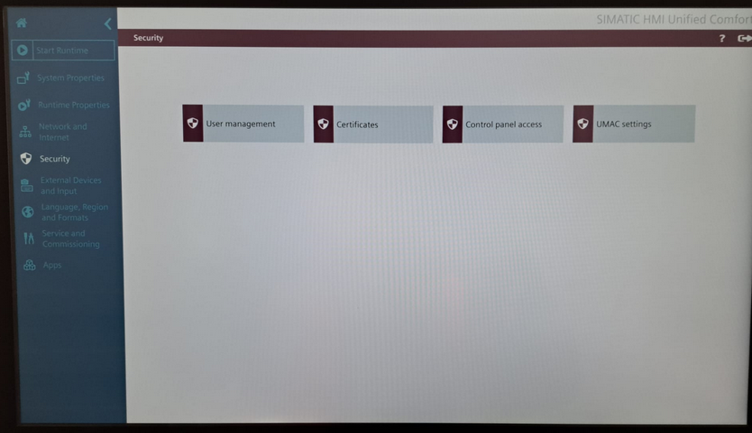
Figure 73. security screen and user management. Comfort panel.
At this point, if you are logged in as an administrator, you can have access to the users as shown below.

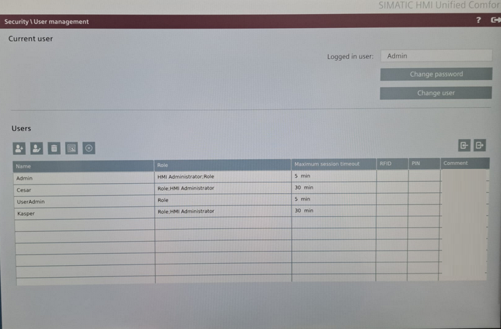
Figure 74. User management. Comfort panel.

During operation ensure that the system is safe to operate. IT IS POSSIBLE TO DAMAGE THE EQUIPMENT AND INJURY PERSONNEL IN MANUAL OR AUTOMATIC MODE.
ONLY QUALIFIED PERSONNEL SHOULD OPERATE THIS MODE.
PAC TECHNOLOGIES REJECTS ANY REPONSIBILITY OF DAMAGE MADE TO EQUIPMENT AND PERSONNEL.

HMI Alarm Screen.

Pressing the " ALARM / MESSAGES " button at the bottom of the screen loads the Alarm screen, this screen shows the user all the faults, warnings, alarms and messages that may be active and a history of them, the screen is shown in the following figure.
1
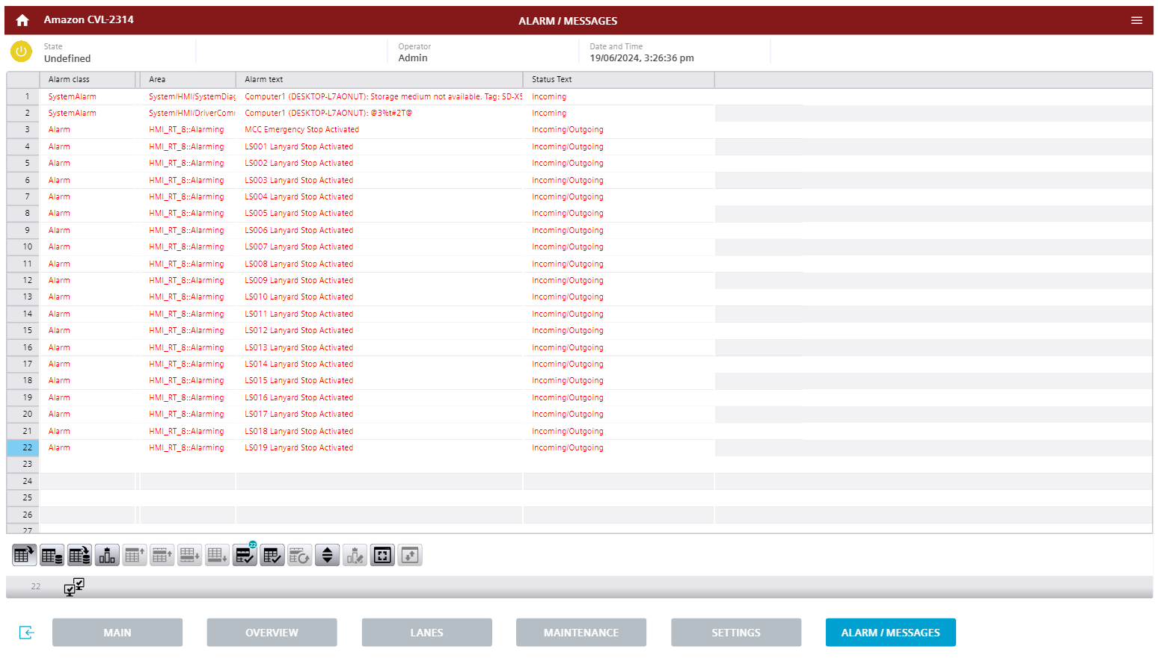
4
4
3
2
Figure 75. HMI Alarm Screen.

The HMI Alarm Screen is composed for:
- CURRENT ALARMS. This table shows the faults, warnings and alarms that may be activated when the user loads this screen, showing the event information in four columns:

- Alarm Class. This column shows the type of message alarm, warning or information
- Date and time. This column shows the date and time of the occurred event.
- Area. This column shows the group to which the occurred event belongs.
- Alarm text. This column shows the message of the event that occurred.
- Status text. Status text. This column shows the status if it is active or not

- Logged alarms. This table shows a record of the faults, warnings and alarms that occurred or to keep a recent record of the events that occurred in the system, like the previous table shows the information of the events in four columns.

- Acknowledged. When the user presses the reset button, the event can be acknowledged and HMI if the event is not still present.

- Navigation control. At this point the user can explore the alarm messages.

References.

- EURME_SCADA_Vendor_Specification_V1Rev10-final.pdf
- EU AMZL Control Systems Specification V2.1.pdf
- Technical-document-IB-P05-EN.pdf
- WinCC_VisualizingProcessesUnified_enUS_en-US.pdf
- CVL-2314-5104001 1.0 - FUNCTIONAL DESCRIPTION.docx

THIS PAGE IS INTENTIONALLY LEFT BLANK

Glossary
- PLC: a programmable logic controller is an industrial computer control system that continuously monitors the state of input devices and makes decisions based upon a custom program to control the state of output devices.
- VSD: a variable speed drives controls the speed and torque of an AC motor by converting fixed frequency and voltage input to a variable frequency and voltage output. System performance can be greatly improved by controlling speed to precisely match the load.
- HMI: A Human Machine Interface is a user interface or dashboard that connects a person to a machine, system, or device. While the term can technically be applied to any screen that allows a user to interact with a device.
- Safety Relays: Safety Relays are devices that implement safety functions. In the event of a hazard, a safety relay will work to reduce to risk to an acceptable level. When an error occurs, the safety relay will initiate a safe and reliable response.
- Photo electric sensor: a photoelectric sensor emits a light beam (visible or infrared) from its light-emitting element. A reflective-type photoelectric sensor is used to detect the light beam reflected from the target.
- 3PH: Three-phase electric power is a common method of alternating current electric power generation, transmission, and distribution. It is a type of polyphase system and is the most common method used to power large motors and other heavy loads.
- DOL. A direct on-line is the simplest type of motor starter. When energised, a direct on-line starter immediately connects the motor terminals directly to the power supply. A DOL motor starter often contains protection devices, and in some cases, condition monitoring. Those requiring remote or automatic control uses an electromechanical contactor to switch the motor circuit.

